

**K.P.H. Weerasinghe**

2136553

**Device Deals: A web application to predict the price of used electric items using machine learning.**

BSc (Hons) in Computer Science and Software Engineering

Undergraduate Thesis Report

University of Bedfordshire

Mr Vibhavi Attigala

**AY October 2022**

# **Abstract**

Selling and buying used items in the second-hand market is not an unusual thing for people all around the world due to the expense of brand-new items. It can be clothes, electric items, furniture, or even vehicles; people prefer purchasing used items to save some money. When discussing the places where people can look for and purchase used items, thrift stores and websites that sell second-hand items take an important place. More than thrift stores, currently online websites that sell second-hand items are more popular among the public because selling and buying through these websites is time-saving, cost-effective, and very convenient. Discussing the way how these websites operate, at the most basic level, these websites allow sellers to post advertisements about their items, and buyers are allowed to view those and purchase the items by contacting the seller. With time, the needs and expectations of people have now increased and websites are nowadays even using advanced technologies such as voice shopping, IoT (Internet of Things), chatbots, and Artificial Intelligence (AI) to provide a better service to the customers. Even though several websites are currently available for selling and buying second-hand electric items, it was identified that many people are facing difficulties in deciding the prices. Therefore, as a solution to this issue, the web application, “Device Deals” will be developed which can generate a predicted price for an item once the details are entered.

# **Acknowledgment**

First of all, I want to express my gratitude to my research supervisor, Mr. Vibhavi Attigala. The guidance and enthusiasm he provided during this entire process were crucial to my ability to finish this project on schedule and with excellent accomplishment. Dr. Gayana Fernando, lecturer in charge of both the Undergraduate Project Module and the Research Methodology Module, has been invaluable in providing me with resources and guidance as I've carried out this study. Moreover, I'd want to express my appreciation to every member of the SLIIT Academy and staff for their helpful instruction and support provided throughout my time there. Last but not least, I want to thank my parents, relatives, and friends from the bottom of my heart for all the love, guidance, and encouragement they gave me while I was pursuing my degree.

**Table of Contents**

**Abstract** 2

**Acknowledgment** 3

**1** **Introduction** 4

1.1 Project Background 4

1.2 Problem statement 5

1.3 Project scope 5

1.4 Aims and objectives 6

1.4.1 Aim 6

1.4.2 Objectives 6

1.5 Project framework 7

1.6 Structure of the report 8

**2** **Literature review** 10

2.1 Introduction 10

2.2 Machine learning 10

2.2.1 Reasons to use machine learning 11

2.2.2 Machine learning categories 12

2.3 Python 14

2.3.1 PyCharm 15

2.4 Bootstrap 15

2.5 Notepad++ 15

2.6 Visual Studio Code (VS Code) 15

2.7 MySQL 16

2.8 XAMMP 16

2.9 Scikit-learn 16

2.10 Online sales market for second-hand electric items 16

2.11 Related research work 17

2.12 Existing systems 19

2.13 Conclusion 20

2.14 Research gap 20

**3** **Methodology** 21

3.1 Agile Software Development 21

3.2 Planning 22

3.3 Requirement gathering and analysis 22

3.4 Design 23

3.5 Implementation 24

3.5.1 Tools, technologies, and other items used 24

3.5.2 Implementation of code 25

3.5.3 Implementation of database 29

**4** **Results and Discussion** 30

4.1 User Interfaces 30

4.1.1 Home Page 30

4.2 Problems encountered 39

4.3 Application requirements 41

**5** **Testing and evaluation** 42

5.1 Test cases 42

5.1.1 Home page 42

5.1.2 Price Predictor 48

5.1.3 Seller 51

5.1.4 Admin 56

5.2 System evaluation 63

**6** **Conclusion and Future plans** 66

6.1 Lessons learned 67

6.2 Limitations 69

6.3 Future work 69

**7** **References** 69

**8** **Appendices** 71

Appendix A 71

Appendix B 72

Appendix C 72

Appendix D 73

**Table of Figures**

Figure 1: Visual representation of the relationship between machine learning and other related fields (Machine Learning For Absolute Beginners, 2017) 14

Figure 2: Machine language categories (Badillo et al., 2020) 15

Figure 3: Usecase diagram 26

Figure 4: code segment 1 29

Figure 5: code segment 2 29

Figure 6: code segment 3 30

Figure 7: code segment 4 30

Figure 8: code segment 5 31

Figure 9: code segment 6 31

Figure 10: Database implementation code segment 1 32

Figure 11: Database implementation code segment 02 32

Figure 12: Home page screenshot 1 33

Figure 13: Home page screenshot 2 33

Figure 14: Home page - Search bar 34

Figure 15: Home page - AI Chatbot 35

Figure 16: Home page predict price 35

Figure 17: Price prediction interface 36

Figure 18: Seller account create interface 37

Figure 19: Seller account login interface 37

Figure 20: Upload new adds interface 38

Figure 21: Myuploads interface 38

Figure 22: Admin signin interface 39

Figure 23: Admin dashboard 39

Figure 24: Dashboard category section 40

Figure 25: Dashboard category list section 40

Figure 26: Dashboard advertisement details section 41

Figure 27: Dashboard seller details section 42

Figure 28: Feedback results 01 67

Figure 29: Feedback results 02 67

Figure 30: Feedback results 03 68

Figure 31: Feedback results 04 69

**Table of Tables**

Table 1: Research gap 24

Table 2: Tools and technologies 28

Table 3: Tools used for documentation 28

Table 4: Test case 1 46

Table 5: Test case 2 47

Table 6: Testcase 3 48

Table 7: Testcase 4 49

Table 8: Testcase 5 50

Table 9: Test case 6 51

Table 10: Testcase 7 53

Table 11: Tesetcase 8 54

Table 12: Tesetcase 9 55

Table 13: Test case 10 56

Table 14: Test case 11 58

Table 15: Test case 12 59

Table 16: Testcase 13 60

Table 17: Testcase 14 62

Table 18: Tesetcase 15 64

Table 19: Test case 16 65

Table 20: Test case 17 66

**Acronyms**

|  |  |
| --- | --- |
| ML | Machine Learning |
| HTML | Hypertext Mark-up Language |
| CSS | Cascading Style Sheets |
| AI | Artificial Intelligence |
| IoT | Internet Of Things |
| WBS | Work Breakdown Structure |
| IDE | Integrated development environment |
| VS Code | Visual Studio Code |

# **Introduction**

## Project Background

Selling and buying used items in the second-hand market is not an unusual thing for people all around the world due to the expense of brand-new items. It can be clothes, electric items, furniture, or even vehicles; people prefer purchasing used items to save some money. When discussing the places where people can look for and purchase used items, thrift stores and websites that sell second-hand items take an important place. More than thrift stores, currently online websites that sell second-hand items are more popular among the public because selling and buying through these websites is time-saving, cost-effective, and very convenient. Discussing the way how these websites operate, at the most basic level, these websites allow sellers to post advertisements about their items, and buyers are allowed to view those and purchase the items by contacting the seller. With time, the needs and expectations of people have now increased and websites are nowadays even using advanced technologies such as voice shopping, IoT (Internet of Things), chatbots, and Artificial Intelligence (AI) to provide a better service to the customers. Even though several websites are currently available for selling and buying second-hand electric items, it was identified that many people are facing difficulties in deciding the prices. Therefore, as a solution to this issue, the web application, “Device Deals” will be developed which can generate a predicted price for an item once the details are entered.

The “Device Dealers” web application allows sellers and buyers to sell/buy second-hand electric items. The sellers are able to post advertisements regarding the items they are going to sell and the buyers will be able to purchase the advertised items just as in all the other buying and selling sites. The unique feature offered by the Device Dealers is the price prediction feature. Once the details related to an electric item (mobile phones only) are entered, a predicted price will be generated by the application making it easy for both sellers and buyers to decide on a reasonable price to sell/buy a desired electric item. In addition to that, this web application will allow the users to search and filter items considering constraints such as product name and category. Moreover, the application also contains an AI chatbot that provides quick and fast solutions to the questions asked by customers.

## 1.2 Problem statement

Selling and buying second-hand goods through e-commerce websites is not an unusual thing all around the world nowadays. When coming to the term, “Second-hand goods”, selling and purchasing used electric items such as mobile phones, laptops, and home appliances can be identified as very common. The e-commerce websites designed specifically for selling and buying used electric items can be seen worldwide, including in Sri Lanka. Even though several websites are currently available within the country which allow selling and buying second-hand electric items, it was identified that many people are facing difficulties in deciding the prices of the items both when selling and purchasing. When going through the websites available in a few other countries, it was identified that most of them have implemented price predictors that generate a predicted price for the items once the related details are entered. The absence of this feature within local websites was identified as the main reason why the users are struggling to decide the prices. Therefore, to address the issue, the need for a similar web application, which generates a predicted price for an item once the details are entered was identified. In addition to the difficulty faced by locals when deciding the prices, it has been noted for a long period of time that the available local websites have been unable to satisfy the users in terms of customer service. The inability to contact the owners of the websites immediately and delays in response were among the major complaints received by existing local websites. As a solution to that, the need of implementing an AI chatbot that provides instant answers to the questions raised by customers was also identified.

## 1.3 Project scope

The web application, “Device Deals”, allows sellers to sell their items by posting an advertisement while the buyers will only be able to contact the sellers through the information published. In order to advertise an item, it is essential for a seller to get registered on the website and all the registered sellers will be able to view the items sold by them along with the published date and the current status. The buyers are only given the chance to view the published product details while the search and filter options will support them to sort out the needed products. There is a price prediction feature implemented, which is accessible to both the buyers and sellers, and through that, they’ll be able to get a price predicted for an item they’re going to buy/sell. There is also an AI Chatbot implemented which provides instant answers to the questions raised by the users. “Device Deals” is limited to Sri Lanka and only the users living within the country premises will be able to purchase and sell products using the website. Moreover, since it is not practical to train data sets for all the categories of electric items, the price prediction feature is only designed to generate predicted prices for used mobile phones.

## 1.4 Aims and objectives

### 1.4.1 Aim

The proposed web application aims to provide a solution to the difficulty faced by sellers and buyers in deciding a reasonable price for used electric items by generating a predicted price.

### 1.4.2 Objectives

* To evaluate the current status of the existing local e-commerce websites which sell used electric items.

* To identify the current issues in existing e-commerce websites which sell used electric items.
* To identify the expectations of the customers who are using local e-commerce websites to sell/buy used electric items.
* To identify and evaluate other similar systems currently in use that make predictions using machine learning.
* To identify the current use of machine learning methods and algorithms.
* To identify the most suitable machine learning algorithm for a value prediction system.
* To develop a well-functioning e-commerce web application that uses machine learning to predict the prices of used electronic items.
* To evaluate future advancements that will take place in e-commerce websites within the upcoming years.

## 1.5 Project framework

Before getting started on the project of developing the web application "Device Deals," a comprehensive feasibility analysis was carried out in order to guarantee that the aims and objectives that were planned for the project are both attainable and feasible. Reading online pages from credible websites, going through journal publications, and referring to previous literature work were the primary ways in which secondary information was obtained for this thesis report. On the basis of the information obtained from the relevant secondary resources, it was determined whether or not the concept could be implemented. The knowledge and information were put through the second round of scrutiny, and the information that was pertinent to this thesis report was presented in the section on the literature study. In addition, because machine learning serves as the basis for this research, a background analysis of the area was carried out in order to evaluate the fundamental ideas, modern applications, and machine learning systems that are currently in use. This research was also helpful in determining which technologies and frameworks for development are complementary to one another. After finishing the inquiry into the project's history, it was decided that the project could be developed in the way that was originally envisioned. The anticipated aims and objectives of the project were then created in order to ensure that the initiative would be successful. The objective of the project is to provide measurable results, and once the project has been finished, the project's goals can be accomplished by ensuring that it was successfully finished. After doing an analysis of the project background and the feasibility, the following step of the project was conducting research on software development methodologies in order to select the most appropriate approach for carrying out the artifact development process. After conducting research into various software development approaches, the decision was made to implement the proposed system using the Agile development methodology. It was essential to carry out project operations in line with the software development methodology that was selected, and feasibility studies assisted in identifying the resources and technology that were required for the development of artifacts. At the outset of the project, a work breakdown structure (WBS) was devised. This structure was created by breaking down the main tasks of the project into small sub-tasks and it assisted in the organization and categorization of the necessary work for each and every component of the project. In addition, the Gantt chart was created to maintain a bird’s eye view of the project and it depicted among other things, how dependent tasks, milestones, and tasks with different start and end dates related to one another. Moreover, to keep track of the progress of the project, a Trello board was maintained by separately managing the ongoing, scheduled, and completed tasks. The artifact development was divided into 5 sprints although each of these sprints had its own planning, designing, implementation, and testing stages. The development of the web application started with designing the main interfaces, including the home page, seller accounts, seller registration, and seller login. In addition to the interfaces, the database was also created during sprint 1. And then during the second and third sprints, the post advertisement feature and price prediction feature were implemented respectively. During sprint 4, the rest of the features related to buyers such as quick view was implemented and in the final stage, sprint 5, the search and filter options were implemented along with the AI chatbot. After the development of the artifact was completed, the next stage, which consisted of testing the web application that was built, was carried out. During this testing phase, the internal unit tests were performed first, followed by user testing to get feedback from the actual users. User testing was carried out by providing a feedback form to be completed by the actual users. Based on the responses received, it was possible to identify the web applications’ strengths and weaknesses, and also the future advancements the users are expecting to see.

## 1.6 Structure of the report

The Thesis report contains 6 main chapters.

1. Introduction
2. Literature Review
3. Methodology
4. Results and Discussion
5. Testing and Evaluation
6. Conclusion and Future Plans

The first chapter, the Introduction, describes the project’s background information, including the problem statement, project scope, aims and objectives, the project framework, and the structure of the Thesis report.

The previous literature is reviewed in the second chapter of the research project, which is titled "Literature Review." This chapter contains a comprehensive and well-organized presentation of recent and past information that is relevant to the research project’s chosen subject of study. In addition to this, it provides a comprehensive analysis of research papers and journal articles that are relevant to the topic, as well as citations to the works themselves. Moreover, in this section, it will be discussed the similar kind of existing systems and also the research gap.

The third chapter, Methodology, describes the techniques used in planning, gathering requirements, designing, and developing stages and also describes the selected software development methodology. Use-case diagrams, and important functional implementation are also stated and discussed in this section.

In the fourth chapter, mainly the final user interfaces designed and the results obtained for the questionnaire will be discussed in detail. In addition, it examines the problems and challenges that arose during the process of creating the web application, as well as the strategies that may be utilized to effectively address and overcome those issues and challenges.

The technique for testing and evaluation is outlined in the fifth chapter, which is titled "Testing and Evaluation." This chapter uses all of the test scenarios and user feedback.

The sixth chapter is titled "Conclusion and Future Plans," and it examines the relevance of the results, how the aims were achieved, the limitations that were discovered, suggestions, and future work.

# **Literature review**

## Introduction

The principal focuses of this research, as well as other relevant works, studies, and organizational structures, are each given their own detailed explanation in the literature review section of this chapter. In addition, the primary objective of this literature review is to identify contemporary technologies and their applications that are founded on machine learning technology. This objective will be accomplished by reviewing recent findings and studies that are relevant to this research. This chapter focuses mostly on covering subjects relevant to machine learning technologies, the online sales market for second-hand electric items, and already existing systems. In addition, relevant research articles and publications were located through the use of keyword searches carried out on web search engines such as Google Scholar (Google et al., 2004) and the ACM Digital Library (ACM, 1947). Reading printed works, reputable pieces on the internet, electronic books, and magazine articles allowed for the accumulation of more information that was needed. Any time this paragraph is brought up, it should be brought to everyone's attention that it is accompanied by citations.

## Machine learning

"Machine learning" refers to the process by which computational algorithms can imitate human intelligence by picking up information from their surroundings (Bi, Goodman, Kaminsky and Lessler, 2019). In other words, according to the modern machine learning book author, Oliver Theobald, the concept of self-learning is the key feature of machine learning (Machine Learning for Absolute Beginners, 2017). As shown in figure 2.2.1, machine learning is also a subfield of computer science and statistics that is at the center of artificial intelligence and data mining, and its expansion is happening at a lightning-fast rate. Recent advancements in machine learning have been made possible by a number of factors, including the development of novel learning algorithms and theories, an ever-increasing amount of available data, and the development of low-cost computing (Jordan and Mitchell, 2015). Successful applications of machine learning have been found in a variety of fields, including computational biology, pattern recognition, computer vision, aerospace engineering, banking, the entertainment industry, and more (Machine Learning in Radiation Oncology, 2015).

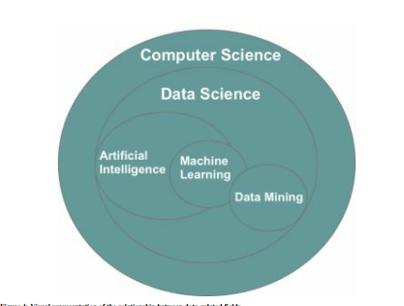

Figure 1: Visual representation of the relationship between machine learning and other related fields (Machine Learning For Absolute Beginners, 2017)

### Reasons to use machine learning

In conventional programming, many different types of systems had to rely on predetermined rule sets, such as "if" and "else" conditions, in order to use user input data and make judgments. In order to reach a conclusion, one must first fulfill a predetermined list of criteria that is unique to the undertaking at hand. Because of this, if there is a change in the mission, the structure needs to be revised. This is because generating decisions demands a profound comprehension of the decision-making process as well as how to generate it. The ability of machine learning to effectively recognize human faces, for instance, is one of its most important features. Because it is difficult to decide which pixels should be utilized to identify a face, hard-coded systems typically fail to correctly recognize a human face. This is because faces are made up of many different pixels. However, by being shown a huge number of photographs of human faces, a machine learning system can learn what details are necessary to recognize a human face (Guido & Müller, 2017). It was expected that making use of machine learning in this research to estimate the market price of a car would yield a result that would be more accurate and valuable than making use of a conventionally hard-coded collection of variables. These considerations led to this belief.

### Machine learning categories

Anyone who works in machine learning, which comprises hundreds of different statistically-based algorithms, faces the ongoing challenge of selecting the appropriate algorithm or combination of algorithms for the task at hand. Machine learning can be categorized as supervised, unsupervised, or reinforcement-based (Machine Learning For Absolute Beginners, 2017).

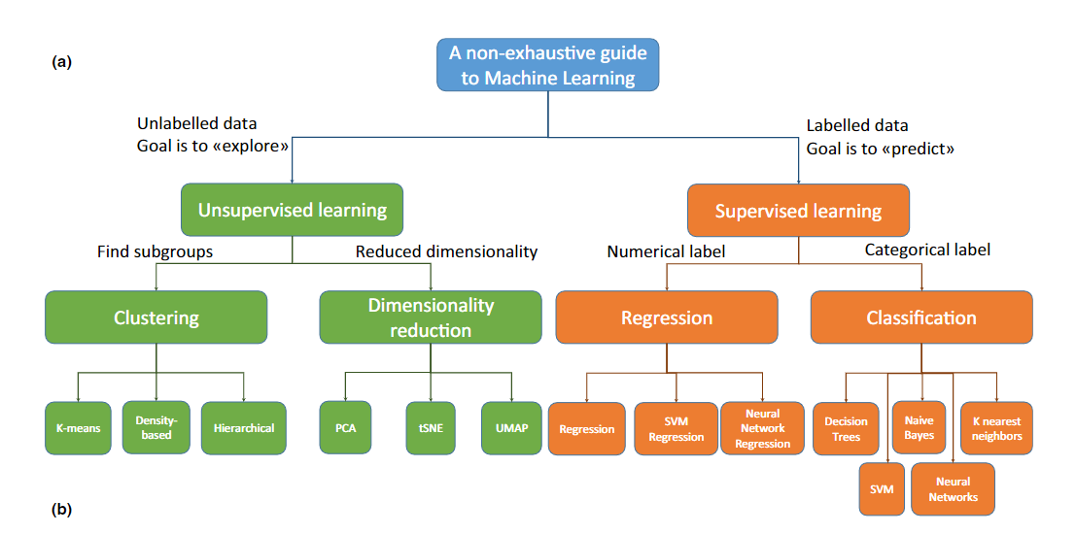

Figure 2: Machine language categories (Badillo et al., 2020)

#### **2.2.2.1 Supervised learning**

In a supervised learning scenario, the computer is given training data to process, which consists of observations and the values that correspond to each known outcome. The objective is to get an understanding of general principles which are also referred to as a "model" that maps inputs to outputs in order for us to be able to predict the output for fresh data that we have not yet seen (Badillo et al., 2020). The first type of supervised learning is classification, which makes use of output values of a categorical nature, and the second type, regression, makes use of output values of a numerical one (Machine Learning For Absolute Beginners, 2017).

##### **2.2.2.1.1 Linear regression**

It is possible to make educated guesses about the value of a variable by doing linear regression analysis and basing those guesses on the value of another variable. The dependent variable is the one whose value you are interested in predicting in the future (Su, X., Yan, X. and Tsai, C.L., 2012). You are basing your estimate of the value of the dependent variable on the value of the independent variable, which you are utilizing to make the forecast. In this sort of analysis, the coefficients of the linear equation are determined with the assistance of one or more independent variables that are able to make the most accurate prediction of the value of the variable that is being analyzed (Gross, J. and Groß, J., 2003). The linear regression method involves minimizing the discrepancies that exist between the expected output values and the actual output values by fitting a straight line or surface. Calculators for linear regression that use the "least squares" method can be used to determine the line that provides the best fit for a set of paired data, and this can be done using the calculators. The value of X, which is the dependent variable, is then estimated with the help of Y. (independent variable). The mathematical method that is used in linear regression models is a straightforward one that may be utilized for the purpose of making forecasts. The application of linear regression is useful not just in business but also in a wide variety of academic fields (Yan, X. and Su, X., 2009). The use of linear regression is widespread across many disciplines, including the social, environmental, behavioral, and environmental sciences, as well as business. Using linear regression models, it is now possible to make predictions about the future using scientific methods and with a high degree of accuracy. Due to the fact that linear regression is a statistical method that has been around for a very long time, the characteristics of linear regression models are well recognized, and the models may be trained in an extremely short amount of time (Yan, X. and Su, X., 2009).

#### **2.2.2.2 Unsupervised learning**

Unsupervised learning does not result in the classification of each and every variable and data pattern (Shalev-Shwartz, S. and Ben-David, S., 2014). Instead, the computer will need to make use of unsupervised learning techniques in order to discover previously concealed patterns and construct labels. Users are able to execute more complex processing tasks with unsupervised learning algorithms as contrasted to supervised learning algorithms. On the other hand, unsupervised learning can be more unpredictable than other natural learning approaches. This machine learning category includes clustering, anomaly detection, neural networks, and various others that are instances (Unsupervised Machine Learning: Algorithms, Types with Example, 2022).

#### **2.2.2.3 Reinforced machine learning**

The third and most sophisticated kind of machine learning algorithm is known as reinforcement learning. Reinforcement learning is a type of learning that, in contrast to supervised and unsupervised learning, continuously improves its model by using the data collected from earlier rounds (Mahesh, B., 2020). This is in contrast to supervised learning and unsupervised learning, both of which can lead to an indefinite endpoint once a model has been constructed based on training and test data. The fundamental difference is in the techniques that are used to train the model over the course of time in reinforcement learning. Outputs are graded rather than tagged in the traditional method of reinforcement learning, and performance requirements are measured in terms of a numerical value (Mahesh, B., 2020).

## Python

Python (Foundation, 1991), one of the programming languages that is currently the most commonly used, is responsible for the development of a wide variety of tools and applications for machine learning. The reason for this lies in the fact that Python is compatible with a variety of scripting languages and frameworks. This is due to the fact that the Python keyword is easier to understand and requires less effort to code than those used in other languages. According to Guido and Müller (2017), machine learning frameworks and tools that are based on Python are widely available. Python and the Django framework were utilized in the development of this research-oriented online application.

### 2.3.1 PyCharm

PyCharm is an integrated development environment (IDE) that is tailored specifically for the Python programming language. It provides Python programmers with access to a broad variety of useful tools. These tools are strongly connected with one another to offer a practical environment for the efficient creation of Python, web, and data science applications.

## Bootstrap

For the purpose of front-end web development that places an emphasis on mobile responsiveness, Bootstrap is a CSS framework that is open-source and free to use. It includes design templates that are based on HTML, CSS, and JavaScript for various interface elements like typography, forms, buttons, navigation, and other components.

## Notepad++

Notepad++ is a text editor and source code editor that is supported by Microsoft Windows. Through the use of tabs, editors are afforded the opportunity to manage many open files inside the confines of a single window. The name of the product comes from the C postfix increment operator, which is where it was first used. Notepad++ is a piece of software that can be downloaded for free.

## Visual Studio Code (VS Code)

Visual Studio Code, more commonly referred to as VS Code, is an editor for source code that was developed by Microsoft. It is compatible with macOS, Linux, and Windows. A number of features, such as support for debugging, syntax highlighting, intelligent code completion, snippets, code refactoring, and embedded Git, are included.

## MySQL

MySQL, a relational database management system, is available without cost and its source code is open to the public. The name of the company comes from the combination of the names "My," which is the name of co-founder Michael Widenius's daughter, and "SQL," which is an acronym for structured query language.

## XAMMP

The primary components of XAMPP, a free and open-source cross-platform web server solution stack bundle developed by Apache Friends, include the Apache HTTP Server, the MariaDB database, and interpreters for scripts written in the computer languages PHP and Perl.

## Scikit-learn

In addition to SciPy, the Python machine learning module known as scikit-learn is also available for download, and it is licensed under the BSD-3 clauses. Skearn is the name of the Python machine learning package that has proven to be the most trustworthy and successful (Skit-Learn). It provides a set of useful tools for statistical modeling and machine learning by way of a Python consistency interface. These capabilities include classification, regression, clustering, and dimensionality reduction.

## Online sales market for second-hand electric items

In spite of the fact that they have been in use since the days of bartering, secondhand goods are gaining popularity among customers all over the world, particularly among members of the X, Y, and Z generations (Hristova, Y., 2019). This is due to the fact that digitalization is taking place. Not just in terms of price, but also in terms of social and ethical considerations, the market for previously owned consumer goods presents an attractive alternative and a formidable threat to the industry standard of brand-new products (Hristova, Y., 2019). When considering the online sales market, attracting potential customers in the initial stage of unknown online stores in the used product market is critical and also a practical issue for retailers (Lee, S.M. and Lee, S.J., 2005).

## Related research work

Even if a number of research papers and literature work were referred to, no research paper was found that exactly addressed the topic, “Web application to predict the price of used electric items using machine learning.” but several papers were found that were about price prediction using machine learning.

Pudaruth, S (2014) conducted a research project on the topic, “Predicting the price of used cars using machine learning techniques” and there he developed an application of supervised machine learning techniques to predict the price of used cars in Mauritius. According to him, the predictions were based on historical data collected from daily newspapers and different techniques like multiple linear regression analysis, k-nearest neighbors, naïve bayes and decision trees have been used to make the predictions (Pudaruth, S ,2014). The predictions then have been evaluated and compared in order to find those which provide the best performances. All the four methods provided have given a comparable performance and, in the future, and he has stated that in the future he is planning to intend to use more sophisticated algorithms to make the predictions.

Asim, M. and Khan, Z. (2018) have conducted research on mobile price class prediction using machine learning techniques. The main goal behind conducting the research was been to identify if the mobile with given the features would be economical or expensive. A Real Dataset has been collected from the website www.GSMArena.com and different feature selection algorithms were used to identify and remove less important and redundant features and have minimum computational complexity. Different classifiers have been used to achieve as higher accuracy as possible and finally results were compared in terms of the highest accuracy achieved and minimum features selected (Asim, M. and Khan, Z., 2018). Conclusion has been made on the base of best feature selection algorithm and best classifier for the given dataset. Future work has been suggested to extend this research and find a more sophisticated solution to the given problem and a more accurate tool for price estimation (Asim, M. and Khan, Z., 2018).

A. Varma, A. Sarma, S. Doshi and R. Nair (2018) have conducted a research project regarding house price prediction using machine learning and neural networks. The main aim of their research project has been predicting housing prices with real factors. They have aimed to make their evaluations based on every basic parameter that is considered while determining the price and have used different regression techniques in this pathway. The results obtained by them are said to be not depending on one single technique rather it is weighted mean of various techniques to get the most accurate results. According to the results obtained, it was identified that the approach used by them yields minimum error and maximum accuracy than individual algorithms applied. They have also proposed using real-time neighborhood details using Google maps to get exact real-world evaluations (A. Varma, A. Sarma, S. Doshi and R. Nair, 2018).

S. Velankar, S. Valecha and S. Maji (2018) have conducted a research project on the topic, “Bitcoin price prediction using machine learning”. They have attempted to predict the Bitcoin price accurately by taking various parameters that affect the Bitcoin value into consideration. For the first phase of the investigation, they have aimed to understand and identify daily trends in the Bitcoin market while gaining insight into optimal features surrounding the Bitcoin price (S. Velankar, S. Valecha and S. Maji, 2018). The data set used by them was consisting of various features relating to the Bitcoin price and payment network over the course of five years, recorded daily. For the second phase of their investigation, using the available information, they predicted the sign of the daily price change with the highest possible accuracy price (S. Velankar, S. Valecha, and S. Maji, 2018).

Sen, J. and Chaudhuri, T.D. (2018) have presented a robust and accurate framework of stock price prediction using statistical, machine learning, and deep learning methods. They have used daily data on stock prices at five minutes intervals of time from the National Stock Exchange (NSE) of India and have aggregated those granular data suitably to build the forecasting framework for stock prices (Sen, J. and Chaudhuri, T.D, 2018). They have contended that the framework, by combining several machine learning and deep learning methods, can accurately model the volatility of the stock price movement, and hence can be utilized for short-term forecasting of the stock price (Sen, J. and Chaudhuri, T.D, 2018. Eight classification and eight regression models, including one on a deep learning-based approach, have been built using data of two stocks listed in the NSE - Tata Steel and Hero Moto. Extensive results have been presented on the performance of the models.

## Existing systems

* **LankaBuySell**

Lankabuysell.com is a local online site that allows users to post classified advertisements and search amongst thousands of advertisements across Sri Lanka. This is not specifically designed for electric items or used items and it allows users to post free advertisements based on a variety of categories including electronics, mobile phones, vehicles, properties, machinery, jobs, and services. The users can get registered on the website simply by providing their name, email address, password, and mobile number. Both buyers and sellers are allowed to post advertisements stating their needs and after choosing the category, the fields: make, model, year, mileage, ad title, description, and price should be filled in order to create the advertisement. This website doesn’t allow users to chat with buyers/sellers or generate predicted price values.

* **SecondHand.lk**

Secondhand.lk is also a local website specially designed for selling second-hand goods in Sri Lanka. It also allows sellers to sell a vast variety of items belonging to different categories such as computers, mobile, electronics, furniture, property, and many others. Searching and filtering of items are allowed based on the area and category meanwhile creating user accounts was not allowed. Sellers are given the opportunity to post advertisements freely after stating all the related details but the chatbot service or price prediction feature was not seen.

* **SaleMe.lk**

The website, SaleMe.lk also enables the selling of used/second-hand electric items. Both the buyers and sellers are needed to get registered in order to get their needs met and the advertisements posted by the sellers will be published after the team has reviewed them. Buyers will be able to browse the catalog of listed equipment by either using the search bar or by drilling down the categories and subcategories and then filtering and sorting based on the desired choices. SaleMe.lk enables seller and buyer negotiation and communication through their automated platform where all the communication/negotiation is assisted by the agents.

## Conclusion

In conclusion, it can be stated that all most all the web applications which are currently available within Sri Lanka to buy/sell second-hand electric items are very basic. Even if the needs and expectations of customers have increased over time, the services and facilities granted by web applications have to improve. Therefore, it can be stated that developing an up-to-date web application with advanced features to sell/buy used electric items within Sri Lanka is definitely a need.

## Research gap

As described in section 2.7, the following table illustrates the available features in each and every website when compared to the proposed project. The Website, LankaBuySell has all the listed features in addition to a chatbot service and price prediction feature. SecondHand.lk has all the listed features available in addition to the capability of creating user accounts and price prediction. SalesMe.lk has all the listed features including a chatbot service but lacks a price prediction feature. The proposed web application will satisfy all of the listed features including the chatbot service and price prediction feature.

|  |  |  |  |  |
| --- | --- | --- | --- | --- |
|  | **LankaBuySell** | **SecondHand.lk** | **SaleMe.lk** | **Proposed Web application** |
| Allow User Accounts | Yes | No | Yes | Yes |
| Post/view advertisements | Yes | Yes | Yes | Yes |
| Search products | Yes | Yes | Yes | Yes |
| Filter products | Yes | Yes | Yes | Yes |
| Chatbot service | No | No | Yes | Yes |
| Value Prediction | No | No | No | Yes |

Table 1: Research gap

# **Methodology**

## Agile Software Development

When developing a software project, it is compulsory to follow a suitable development methodology. A software development methodology refers to structured processes involved when working on a project that provides a systematic approach to software development (8 Best Software Development Methodologies, 2022). While there are a number of development methodologies available, for developing this web application, the Agile methodology is used. Agile software development methodology refers to a collection of methodologies that emphasizes iterative development (What Is Agile Methodology in Project Management? 2022). In this methodology, requirements and solutions can be subjected to change as a result of collaboration among cross-functional self-organizing teams. The most important advantage of using agile software development is that it enables the delivery of software products more quickly, while simultaneously improving quality and predictability, and increasing their ability to adapt to changing circumstances.

## Planning

The first thing to do when preparing a project is to select a subject matter that is applicable and helpful. In order to get the study off to a good start, it was essential to focus one's attention intently on the topic that had been selected. After that, arrives the process of figuring out the project's objectives and goals. As soon as the concept and the structure were confirmed, a process to collect requirements was initiated. Reading older research papers and publications, in addition to looking at other systems that are comparable and have been developed in the same industry, helped to establish a fundamental understanding of the topic.

Following the completion of the first plan for the project, a WBS and a Gantt chart were developed in order to display the project's milestones. They provided a timeline for the project that was more efficient as well as dependable. The project was broken up into five different sprints so that it could be completed using the agile technique. In order to successfully conclude the project, each of these sprint components had its own individual set of responsibilities that needed to be fulfilled. The Gantt chart for the project as well as the WBS are available in Appendix Section A and B respectively.

## Requirement gathering and analysis

Requirement gathering was done in two ways: primary data gathering and secondary data gathering. First, in primary data gathering, a questionnaire with 10 questions was created and sent online to a randomly selected set of sellers and buyers who are using web applications to buy/sell used electric items. From the received responses, 35 were selected and analyzed in order to arrive at conclusions. In addition to that several interview sessions were also conducted with selected individuals to gather further details. Secondly, in secondary data gathering, existing systems, journal articles, research papers, and literature work were referred to and evaluated in order to discover linked work and research gaps.

## Design

This section describes how the project is designed for each component of the web application separately. The use case diagram given below illustrates how different users interact with the web application.

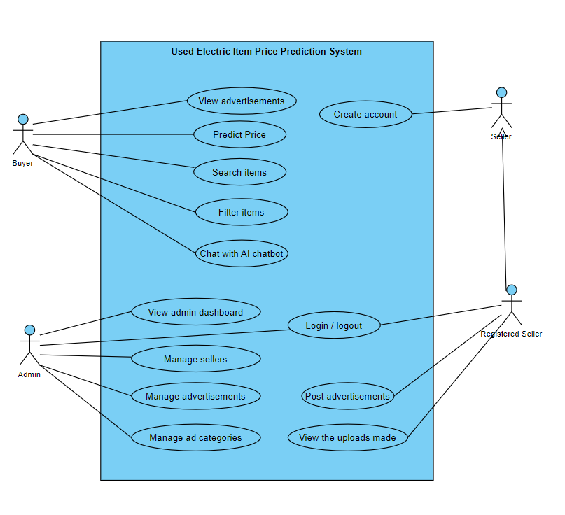

Figure 3: Use case diagram

## Implementation

The process of implementation was carried out in accordance with the agile software development methodology over the course of five separate sprint stages. In each of these sprints, there are certain tasks that need to be finished, such as planning, developing, implementing, and testing. The requirements and discoveries made during the feasibility study were used to guide the selection and selection process for the tools and technologies. In the following table, you will find a list of the tools, technologies, and libraries that were utilized in the process of creating the artifact.

### Tools, technologies, and other items used

|  |  |  |
| --- | --- | --- |
| **Tool / Technology** | **Version** | **Used for** |
| Python | 3.9.0 | Python was selected because of its popularity in the development of machine learning systems, its built-in libraries, the number of Python-based frameworks, and its simplicity of use as compared to other programming languages. |
| PyCharm | PyCharm 2021.2. | PyCharm was used as the IDE for developing the machine learning section. |
| MySQL | 8.0 | MySQL was used as the database. |
| VS Code | Version 1.69 | VS Code was used as the code editor for front-end designing. |
| Bootstrap | Bootstrap 5 | Was used for designing the web application GUIs. |
| XAMPP | 7.4.29 | Was used as the web server |

Table 2: Tools and technologies

In addition to the above-listed tools and technologies, the below libraries were also used in the implementation process.

1. Pandas library
2. Scikit-learn

The tools listed in table 3, were used for documentation and other related work.

|  |  |  |
| --- | --- | --- |
| **Tool** | **Version** | **Used for** |
| Microsoft Word | 2018 | Was used for preparing all the project documentation |
| Microsoft PowerPoint | 2018 | Was used for preparing the project presentation. |
| Project Libre | 1.9.2 | Was used to prepare Gantt Chart |
| Adobe Photoshop CC | 2015 | Was used to prepare the project poster |
| Visual Paradigm | 16.3 | Was used to create diagrams. |

Table 3: Tools used for documentation

### Implementation of code

* Home page

The below screenshot depicts the code segments which create the home page. The title “Device Deals” is set to appear in the middle while a button “Predict Price” is also included which directs the user to the Price Prediction interface when clicked on.

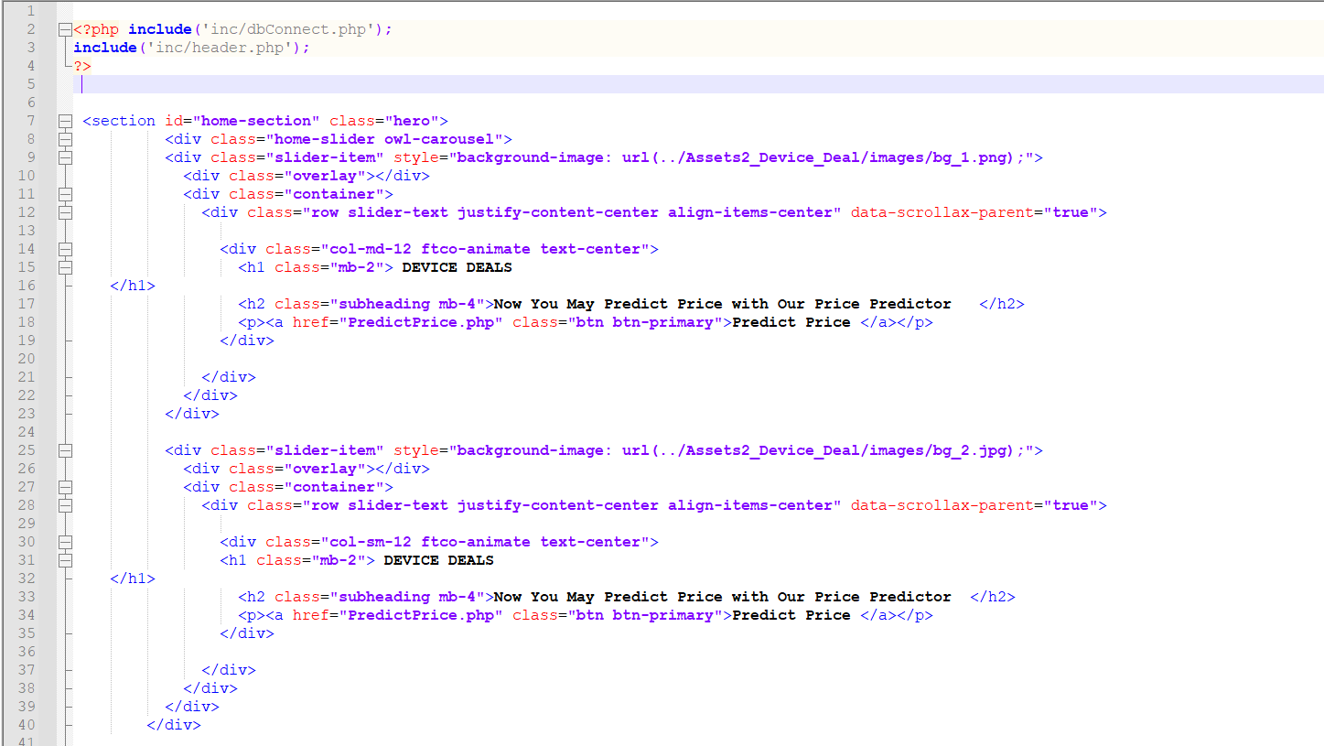

Figure 4: code segment 1

The below screenshot shows the coding for the “Search” function where once the user enters a product name and clicks on the “Search” button, the relevant products will be filtered out and displayed.

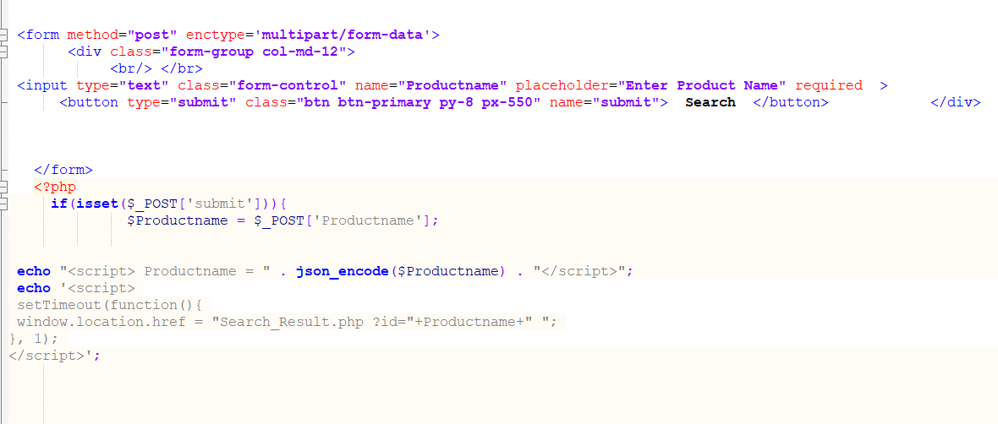

Figure 5: code segment 2

The below code segment is related to the Chatbot. It connects the intent created in the Dialog Flow to the web application.

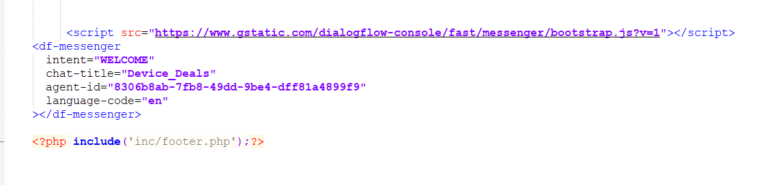

Figure 6: code segment 3

The below cord segment is for the price predictor interface. Once the “Predict” button is clicked on, the entered data will be captured and the predicted price will be generated.

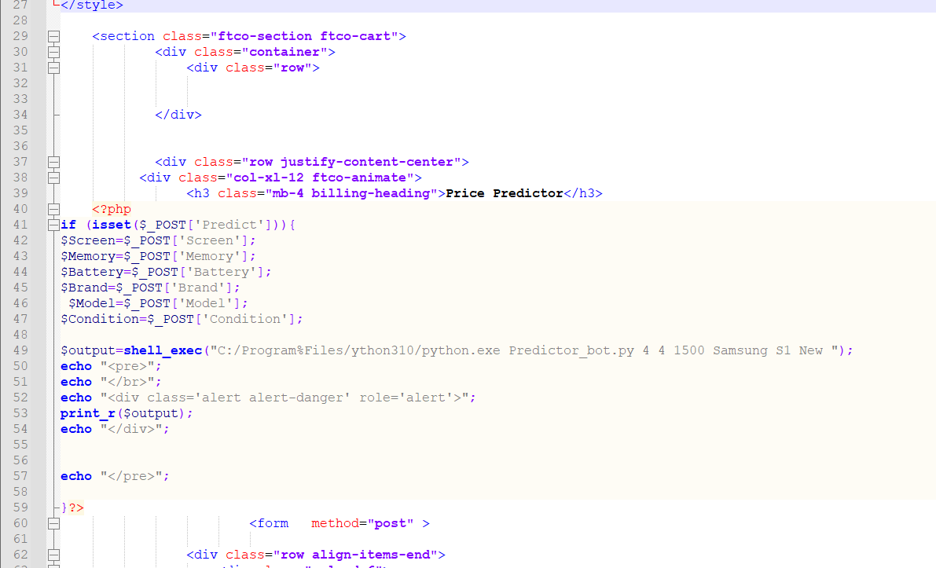

Figure 7: code segment 4

The below code segment is the machine learning section coded using python. Each and every function of the separate code segments are included as comments.

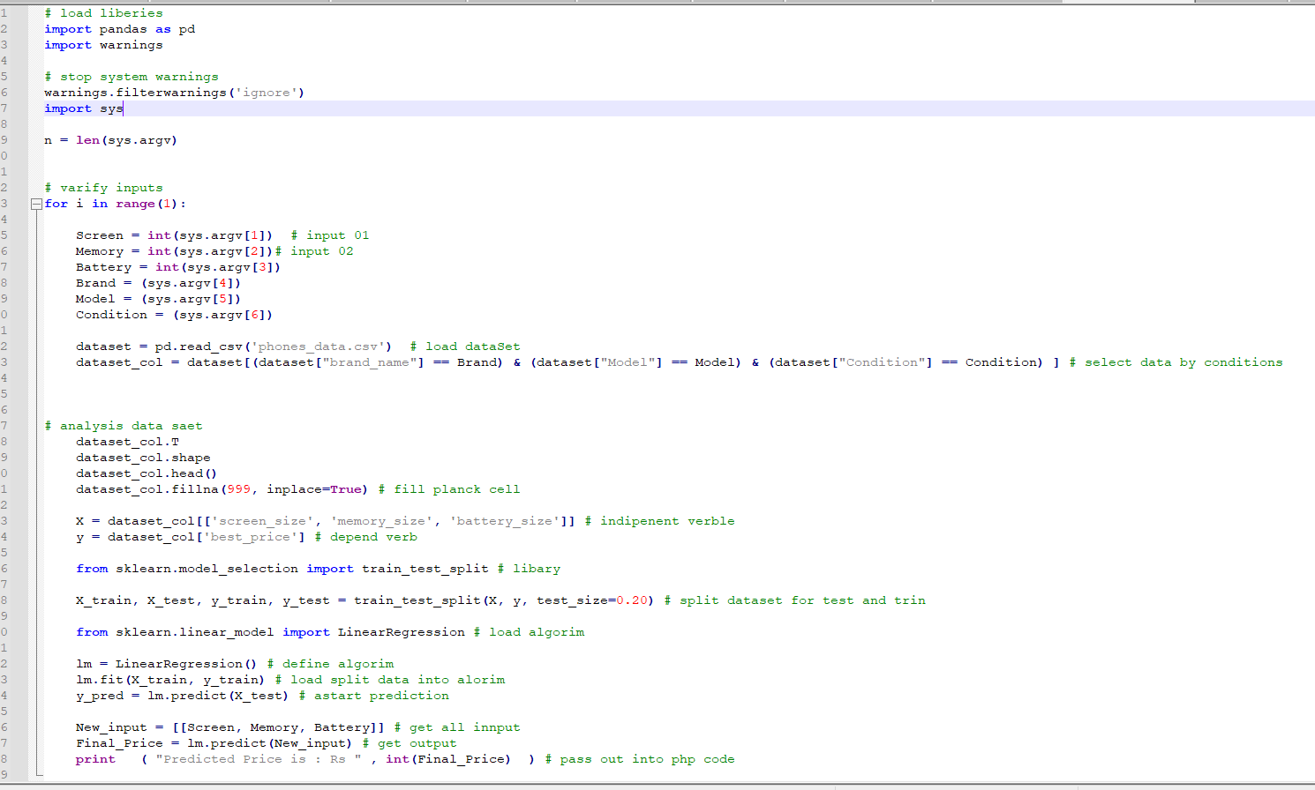

Figure 8: code segment 5

The below code segment is for seller account creation. Once the details relevant to seller account creation are entered by the user, they will be checked for the existing data and only the new data will be saved.

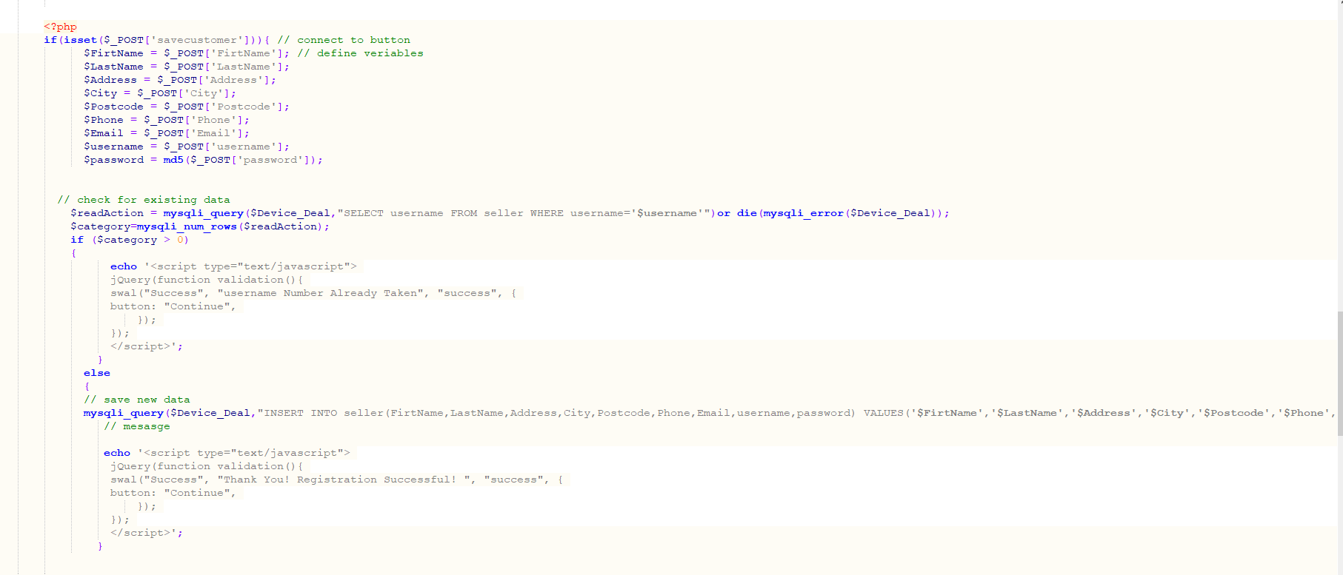

Figure 9: code segment 6

### Implementation of database

As shown in the figure 10 given below, the database was created using MySQL and four separate tables were created category, products, seller and system users. The code segment in figure 11, depicts how the database connection was made with the Developed Web Application.

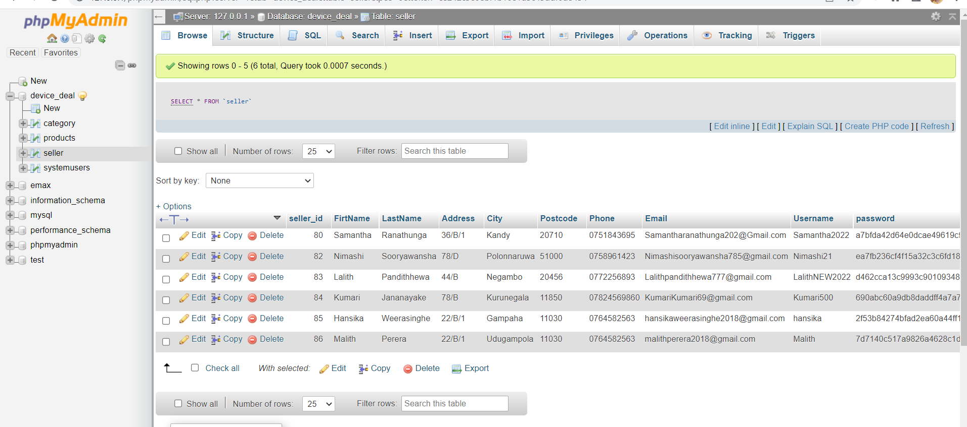

Figure 10: Database implementation code segment 1

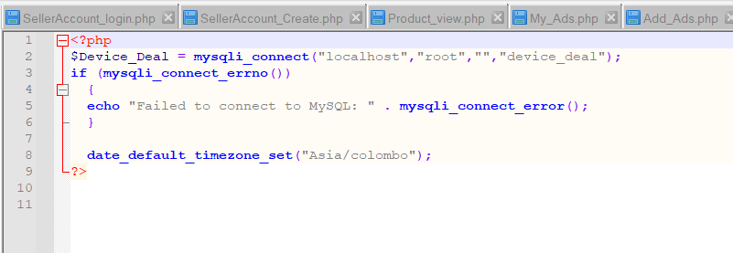

Figure 11: Database implementation code segment 02

# **Results and Discussion**

## User Interfaces

### 4.1.1 Home Page



Figure 12: Home page screenshot 1

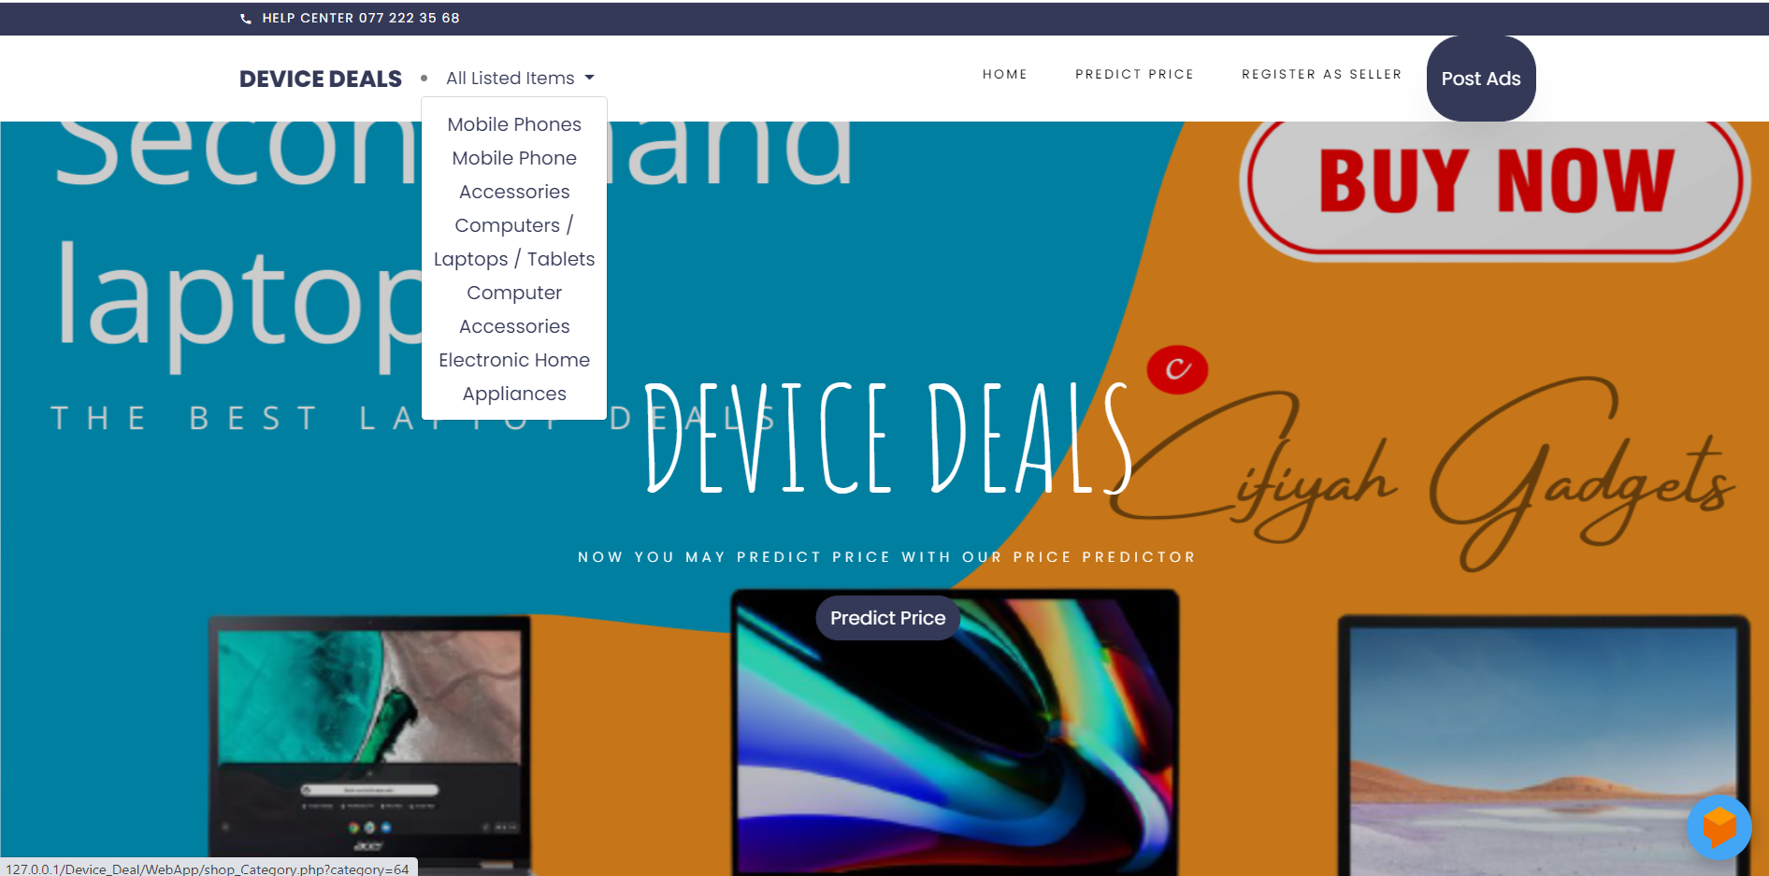

Figure 13: Home page screenshot 2

As shown in figure 4, the main user interface to appear after the application is loaded is the home page. The navigation bar available at the top of the home page is fixed and all the other web pages are linked to it. As shown in figure 5 once the “All Listed Item” is clicked on, a drop-down list will appear, listing all the available item categories. Currently, there are 9 item categories included: Mobile phones, mobile phone accessories, computers/laptops and tablets, computer accessories, and electronic home appliances. The user can click on any category and the available advertisements of the items belonging to the category will be filtered out from the rest and shown to the user.

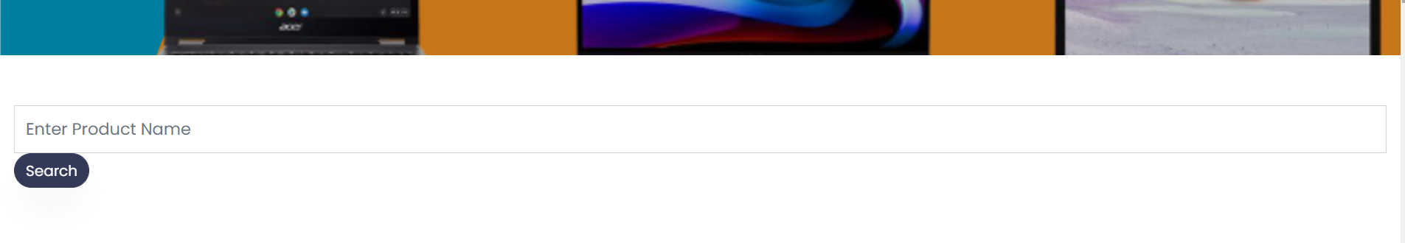

Figure 14: Home page - Search bar

There is also a search bar included on the home page which allows the users to search the posted products by the product name. Once the user has entered the product name in the text field available, he can click on the “Search” button and the relevant products will be listed below. The “Quick View” section allows the users to quickly access the products related to different categories. For example, if the “Mobile Phones” button is clicked on, all the posted mobile phones will appear below, and similarly, if the “Laptops/tablets” button is clicked on, all the available Laptops and tablets will be shown.

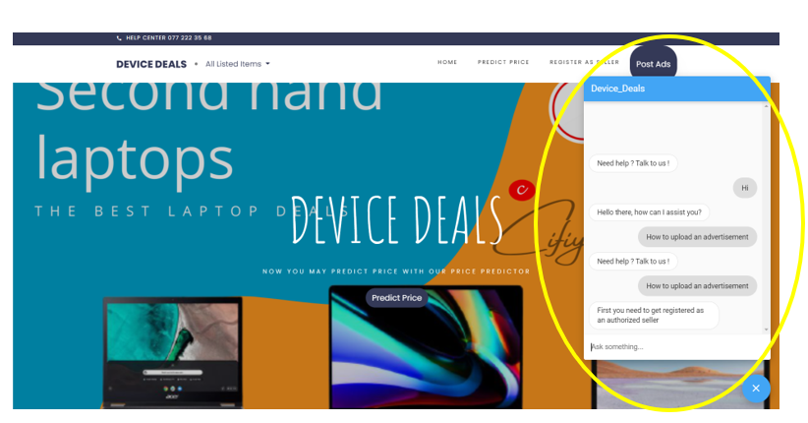

Figure 15: Home page - AI Chatbot

The home page also contains, an AI Chatbot integrated using Dialog Flow. As shown in figure 7, the chatbot will provide automated answers to the questions asked by the users.

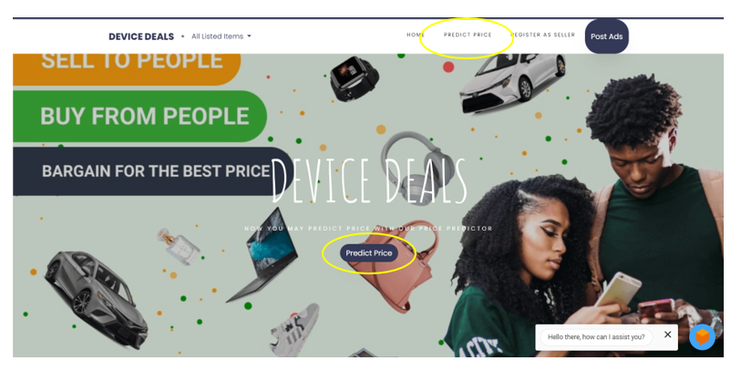

Figure 16: Home page predict price

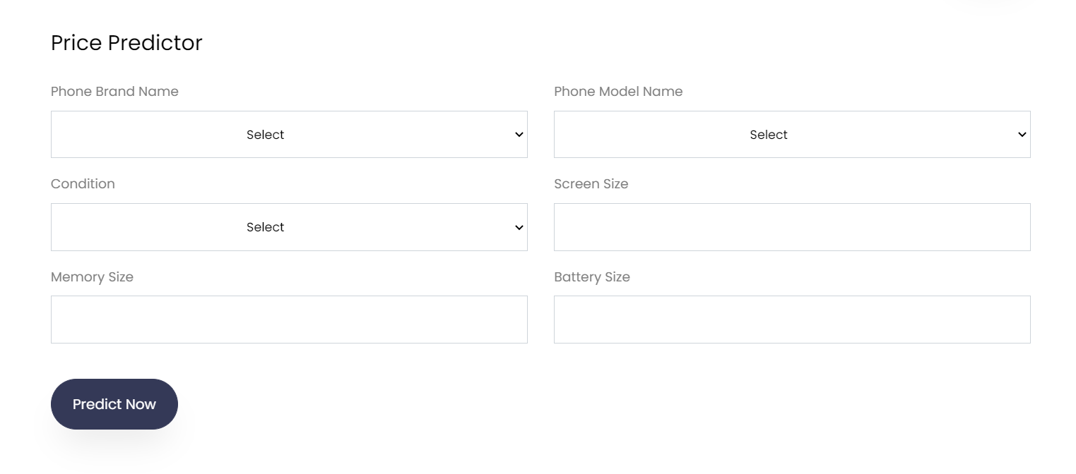

Figure 17: Price prediction interface

The Price Prediction feature can be accessed by clicking on the “Price Prediction” button as well as by selecting the “Predict Price” in the navigation bar. The price predictor takes the phone brand name, phone model name, condition, screen size, memory size, and battery size as inputs. The phone brand name, model name, and condition can be selected from the options listed in the drop-down list. Once the relevant details are entered, the user should click on the “Predict Now” button to get the predicted price.

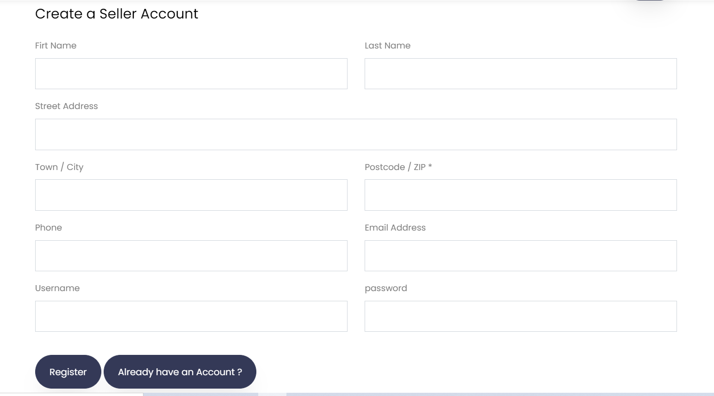

Figure 18: Seller account create interface

Once the “Register as seller” section in the navigation bar is clicked on, the seller registration interface appears. A seller should enter his first name, last name, street address, town/city, postcode, phone, email address, username, and password to create an account. Once the details are entered, it is needed to click on the “Register” button to complete the registration process. By clicking on the “Already have an account” button it is possible to get directed to the seller login interface.

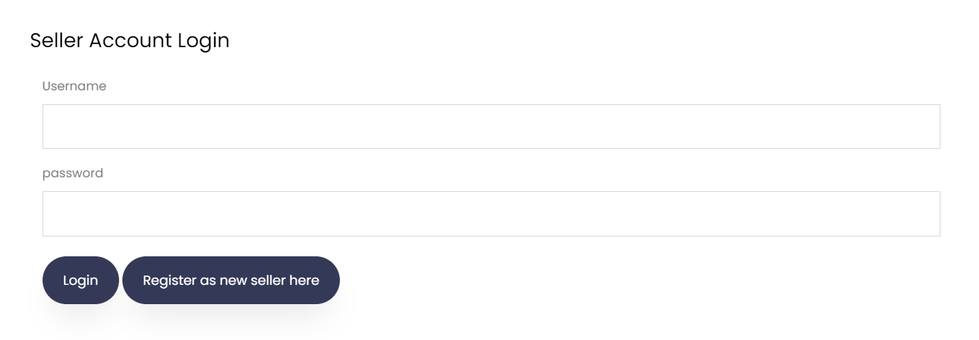

Figure 19: Seller account login interface

A registered seller can log in to his account through the seller account login interface. The seller needs to enter his username and password and click on the “Login” button to get logged in to his account. Once the “Register as a new seller here” button is clicked on, the user will get directed to the “Create a Seller Account” interface.



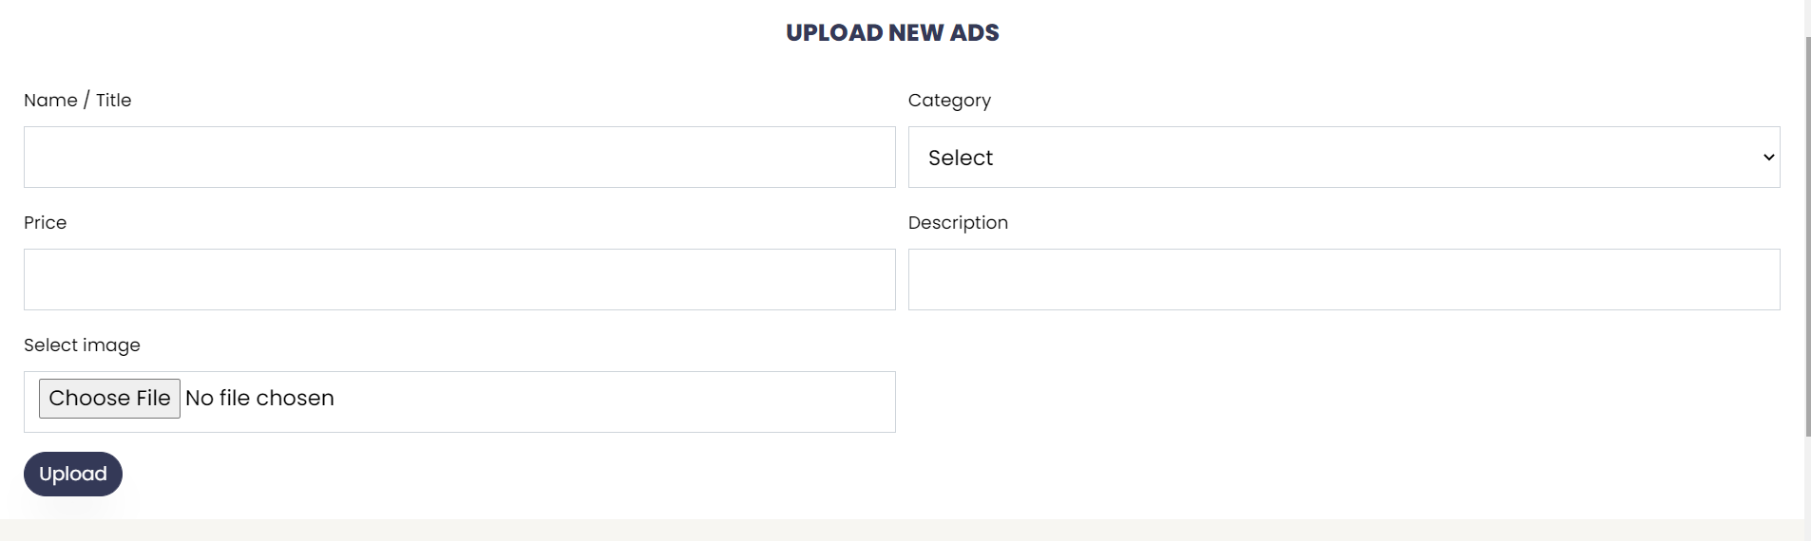

Figure 20: Upload new adds interface

Once the seller has got logged in to his account, he will be able to upload advertisements. The name of the item, category, price, description, and image of the items should also be selected. The category of the item can be selected from the drop-down list. Once all the necessary details have been entered, the “Upload” button should be clicked on to complete the process of posting an advertisement.

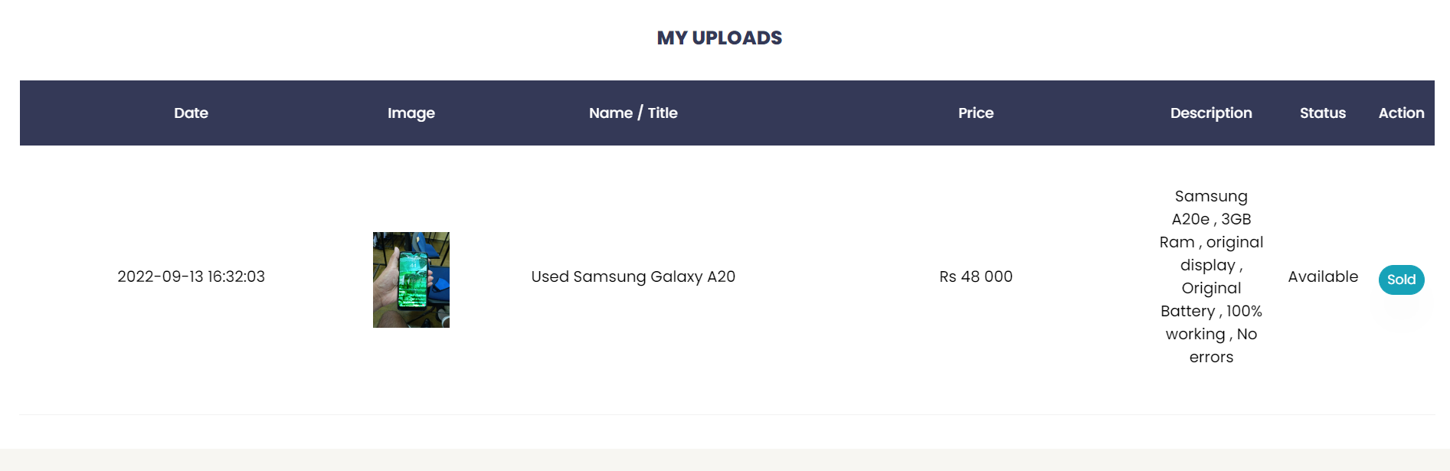

Figure 21: Myuploads interface

Through the “My Uploads” interface, the user will be able to view the advertisements published by him. The date of publish, the image of the item published, the name/title of the item, price, description, status, and the action are displayed through this interface.

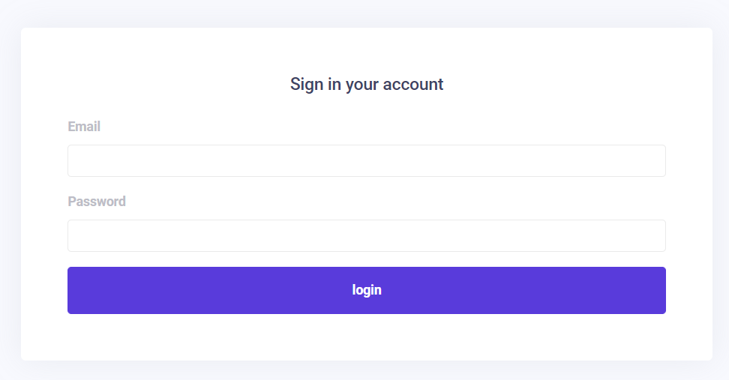

Figure 22: Admin signin interface

Through this interface, the admins will be able to login into the web application. The admins need to enter the email address and the password to log in and click on the “Login” button.

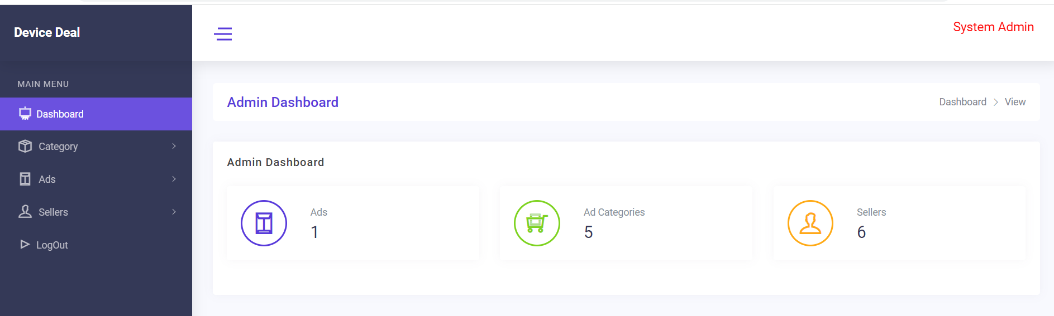

Figure 23: Admin dashboard

The figure depicts the admin dashboard. The admin dashboard shows the total number of ads posted, the number of added advertisement categories, and the count of registered sellers.

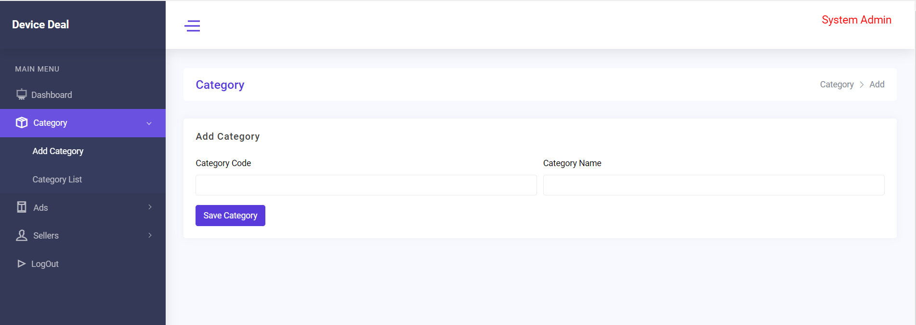

Figure 24: Dashboard category section

The figure shows the Add category section which is available under Category. The admin will be able to add new item categories through this interface. The category code and the category name should be entered and the button “Save category” should be clicked on to add the category to the database.

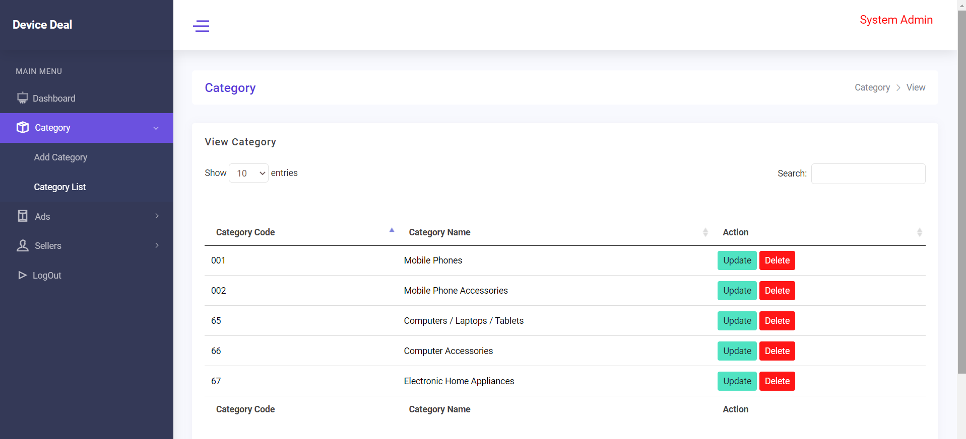

Figure 25: Dashboard category list section

The category list option which comes under the category depicts the available categories along with the category code, category name, and the action. Through this section, the admin is able to update and delete the available categories.

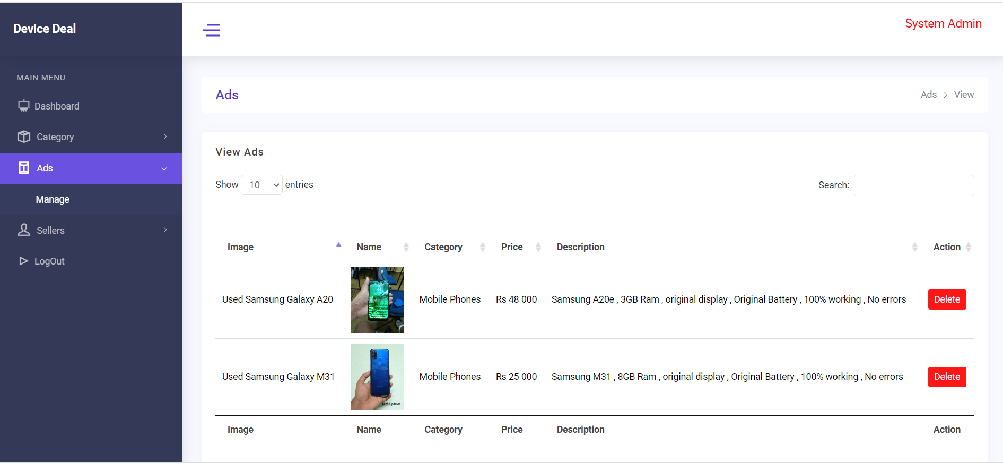

Figure 26: Dashboard advertisement details section

Through the Manage section, which comes under Ads, the admin is able to view the published advertisements and delete them if needed.

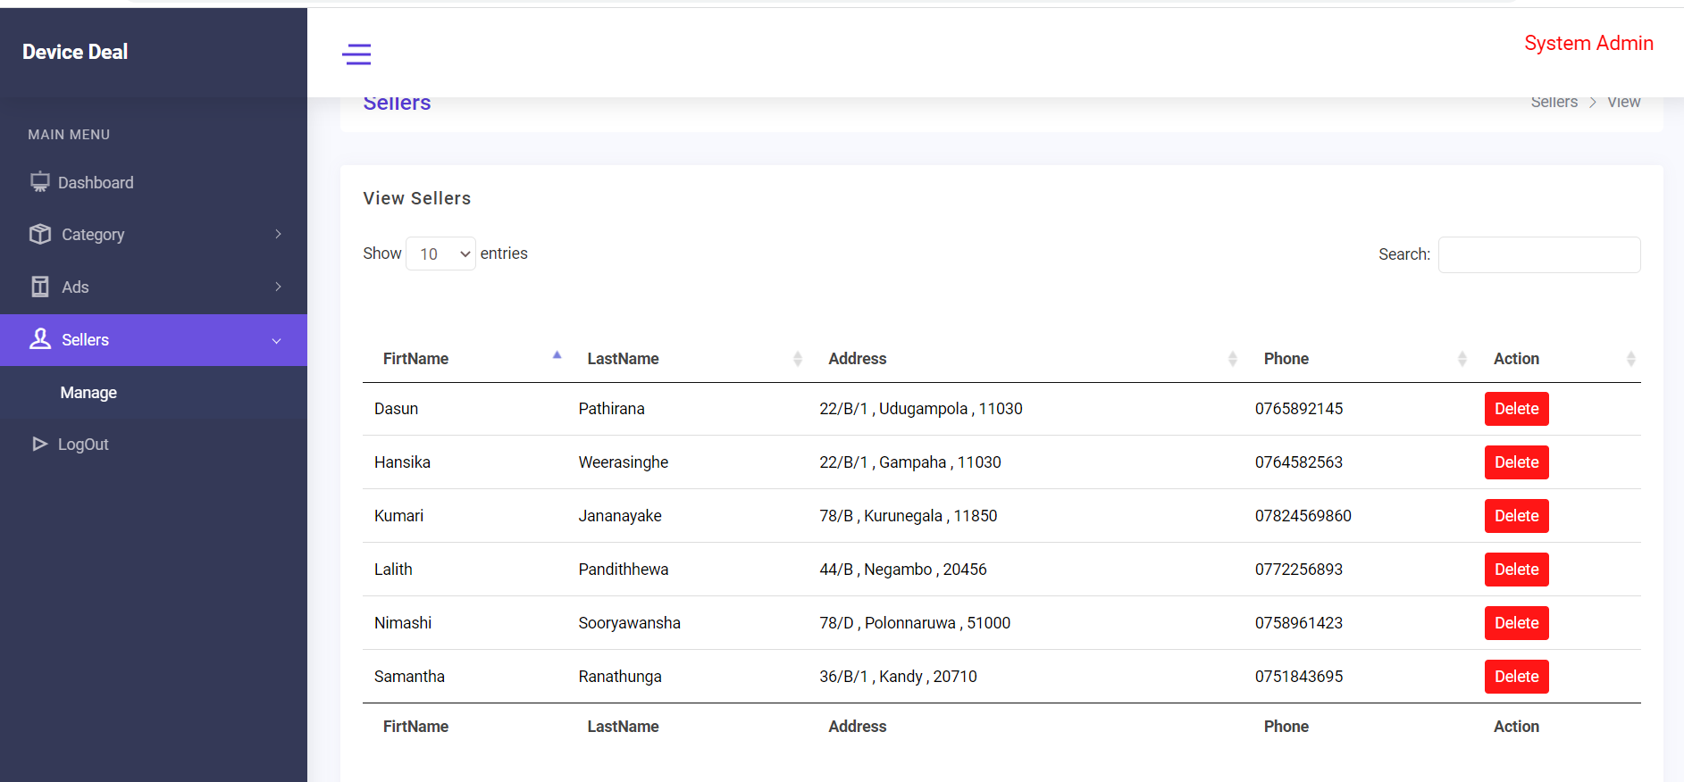

Figure 27: Dashboard seller details section

Through the Manage section which comes under, sellers, the admin will be able to view the registered sellers and remove any of them if needed.

## Problems encountered

Throughout the project from the planning stage to the implementation stage, the researcher faced different problems and challenges. During the requirement gathering and analysis phase, one of the major problems encountered was that several respondents chosen were having poor English knowledge and were incapable of filling up the Questionnaire in English. As a solution to the issue, the questions in the Questionnaire were translated into the Sinhala language as well. Moreover, support and guidance were provided to the respondents through voice calls and zoom meetings. The second challenge faced during the requirement gathering and analysis phase was that some of the respondents were having poor technical knowledge and were incapable of handling the questionnaire. Addressing that issue, support and guidance were again provided through voice calls and zoom meetings. Thirdly, several responses received out of the 35 were found incomplete and not up to the expected standard. As a solution, a total of 50 responses altogether were gathered and then 35 best responses were chosen out of them. As the fourth problem faced during the requirement gathering and analysis phase, due to the prevailing fuel issue and COVID -19 risk, it was difficult to conduct the interview sessions physically with the interviewees, and as a solution the online platform, Zoom was used to conduct the interview sessions. Even if the solution applied provided an answer to the original issue, another problem appeared once the platform was changed to Zoom. The meeting time duration allowed for free zoom accounts was limited to 40 minutes which was not enough to complete an interview session without interruption and even upgrading the account to the premium version just for this task was also a waste of money. So, in order to address that problem, the login details were requested from an already purchased premium account from a friend. Moreover, noting down the facts by hand while the interview was going on was found to be time-consuming and it also interrupted the flow of the interview session. Besides it was unable to take down notes quickly parallel to the interviewees’ speed of speaking. So, several important points were missed, and had to request the interviewee to repeat what is said. Addressing that issue, it was decided to use the record option and screen-record the interview sessions so the facts can be leisurely noted down. Since the session was recorded, it was even possible to rewind and note down any missed points. Another main issue faced while gathering secondary data was that to view some of the research papers fully, it was needed to gain access through the institution, and as a solution to that problem, access was requested from the SLIIT Academy.

During the designing and development phase also a set of problems arose. The main problem identified was the lack of knowledge and skill. Since the researcher was a beginner in the subject, Web Application Development, the knowledge had was insufficient to develop the proposed web application. Addressing the issue, the researcher followed web application development tutorials on YouTube and received support and guidance from the supervisor as well as from peers who are experts in the subject. Then again, implementing the price prediction feature which was developed using machine learning caused many troubles. Machine learning was a completely new subject and the lack of knowledge and understanding brought a lot of stress and confusion. The guidance received from the supervisor and following video tutorials from the most basic stage provided solutions to the issue and finally, it was possible to successfully implement the price prediction feature without any errors. The researcher also had to change the development platforms proposed in the project proposal since more convenient, appropriate, and easy-to-learn platforms were identified later. For example, in the proposal, it was mentioned by the researcher that PostgreSQL will be used as the database but in the final web application, a MySQL database was implemented. Constant power cuts also interrupted the development process and as a result, the researcher faced time management issues in the initial stage. Addressing the issue, strict deadlines were made prior to the actual deadline to get motivated to complete the tasks due early. Moreover, the researcher also faced issues when establishing the connection between the front-end and the back-end. Solving the issue, support and guidance were received from peers, and finally, it was possible to successfully implement a fully functioning bug-free web application.

Challenges and issues were also faced during the documentation process as well. In the feedback received for the project proposal, it was highlighted that the project objectives which the researcher has identified were poor. Addressing the issue, the proposal was shared with the supervisor, and under his guidance, the objectives were clearly identified. Again, an access issue arose while writing the literature review which needed previous literature work referred. Solving the issue, the supervisor was contacted and with his permission access was received from the SLIIT Academy. Additionally, to generate citations, the researcher used a free online reference generator but was advised by the supervisor to use MS Word citation generator. Since the online plagiarism checking sites were not very accurate, getting the documents checked accurately for plagiarism was also an issue. As a solution, support was received from the supervisor to get the documents checked through Turnitin. Again, time management issues were faced during the documentation process as well, and to address the issue, strict deadlines prior to the actual deadline were made ensuring the work will be completed before the final date of submission.

## Application requirements

For the proper functioning of the developed web application, the following resources and requirements are identified to be needed,

1. Stable internet connection
2. Updated web browser
3. XAMPP web server installed
4. MySQL database

# **Testing and evaluation**

The system testing phase was an essential part of successfully completing the "Device Deals" online web application. After each phase of implementation in the process of creating the artifact, there was a testing phase following the stage. This process followed the Agile methodology and was split down into five separate sprints. The primary objective of this test, which eventually became known as unit testing, was to locate and fix errors in newly written and implemented sections one at a time. This method was crucial to the testing process. It was always necessary to utilize a web browser in order to inspect and test the outcomes of the work that was done in establishing the online application. After the five sprints have been completed, it is absolutely necessary to organize and evaluate all of the test cases. During the final step of this testing phase, integration testing and system testing were carried out, and the results of all of those tests suggest that the system that was developed does not have any significant flaws or problems. In the end, but certainly not least, an evaluation procedure was carried out to ensure that the project had been successful in achieving its set goals and objectives. To gather feedback from the users, a simple questionnaire was prepared and handover to sellers and buyers who are currently using other local websites to sell/buy used electric items.

## Test cases

The procedure for developing an artifact includes a total of five sprints, each of which is accompanied by its own collection of written test cases. In order for each sprint to be useful for unit testing, the projected amount of implementation work must be finished during the sprint. This section provides a comprehensive breakdown of each and every repeated test scenario. Each test case includes images of the relevant UI implementations. This is done so that the test case and its findings may be understood in a more comprehensive manner.

### Home page

|  |  |
| --- | --- |
| **Test Case ID** | TC01 |
| **Test Case Name** | Testing the home page for loading |
| **Test Case Description** | Through this test case, it is tested if the home page is getting loaded |
| **Expected outcome** | The home page should get loaded |
| **Actual outcome** | Worked as expected |
| **Status** | PASSED |
|  | |

Table 4: Test case 1

|  |  |
| --- | --- |
| **Test Case ID** | TC02 |
| **Test Case Name** | Testing the search function |
| **Test Case Description** | Through this test case, it is tested if the search function is working as expected |
| **Expected outcome** | Once a product is being searched using the search bar, the relevant products should get filtered out and displayed |
| **Actual outcome** | Worked as expected |
| **Status** | PASSED |
|  | |

Table 5: Test case 2

|  |  |
| --- | --- |
| **Test Case ID** | TC03 |
| **Test Case Name** | Testing the Quick Search |
| **Test Case Description** | Through this test case, it is tested if the Quick search function is working as expected |
| **Expected outcome** | Once the relevant category is selected, all the advertisements belonging to the category should be displayed |
| **Actual outcome** | Worked as expected |
| **Status** | PASSED |
|  | |
|  | |

Table 6: Testcase 3

|  |  |
| --- | --- |
| **Test Case ID** | TC04 |
| **Test Case Name** | Testing the proper functioning of the drop-down list in all listed items |
| **Test Case Description** | Through this test case, it is tested if the drop-down list in all listed items is working as expected |
| **Expected outcome** | Once the “All Listed Items” is clicked on, a drop-down list should appear listing all the available categories of items. |
| **Actual outcome** | Worked as expected |
| **Status** | PASSED |
|  | |
|  | |

Table 7: Testcase 4

|  |  |
| --- | --- |
| **Test Case ID** | TC05 |
| **Test Case Name** | Testing the proper functioning of the filtering function |
| **Test Case Description** | Through this test case, it is tested if the product filtering process is happening as expected |
| **Expected outcome** | Once a category of product is selected from “All Listed Items”, the relevant products should get filtered out and displayed. |
| **Actual outcome** | Worked as expected |
| **Status** | PASSED |
|  | |
|  | |

Table 8: Test case 5

|  |  |
| --- | --- |
| **Test Case ID** | TC06 |
| **Test Case Name** | Testing the proper functioning of the Chatbot |
| **Test Case Description** | Through this test case, it is tested if the Chatbot feature is functioning properly |
| **Expected outcome** | Once the user enters a question, the chatbot should provide the relevant answer. |
| **Actual outcome** | Worked as expected |
| **Status** | PASSED |
|  | |

Table 9: Test case 6

### Price Predictor

|  |  |
| --- | --- |
| **Test Case ID** | TC07 |
| **Test Case Name** | Testing the loading of the “Price Prediction” button |
| **Test Case Description** | Through this test case, it is tested if the price prediction button available on the home page is functioning properly |
| **Expected outcome** | Once the “Price Prediction” button is clicked on, the price prediction interface should get loaded. |
| **Actual outcome** | Worked as expected |
| **Status** | PASSED |
|  | |
|  | |

Table 10: Testcase 7

|  |  |
| --- | --- |
| **Test Case ID** | TC08 |
| **Test Case Name** | Testing the proper functioning of the Price Prediction feature |
| **Test Case Description** | Through this test case, it is tested if the price prediction feature is functioning as expected. |
| **Expected outcome** | Once the details relevant to a mobile phone is entered and the “Predict Now” button is clicked on, the predicted price should be displayed. |
| **Actual outcome** | Worked as expected |
| **Status** | PASSED |
|  | |

Table 11: Test case 8

### Seller

|  |  |
| --- | --- |
| **Test Case ID** | TC09 |
| **Test Case Name** | Testing the registration of a seller |
| **Test Case Description** | Through this test case, it is tested if the seller registration function is working properly. |
| **Expected outcome** | Once the details relevant to register a seller has been input and clicked on the button “Register”, the seller should get registered into the web application. |
| **Actual outcome** | Worked as expected |
| **Status** | PASSED |
|  | |

Table 12: Tesetcase 9

|  |  |
| --- | --- |
| **Test Case ID** | TC10 |
| **Test Case Name** | Testing the proper functioning of the Seller login |
| **Test Case Description** | Through this test case, it is tested if the seller login is working properly |
| **Expected outcome** | Once the user credentials are entered, the user credentials should be validated and the sellers should be able to log in to their accounts. |
| **Actual outcome** | Worked as expected |
| **Status** | PASSED |
|  | |

Table 13: Test case 10

|  |  |
| --- | --- |
| **Test Case ID** | TC11 |
| **Test Case Name** | Testing the proper functioning of the advertisement upload feature |
| **Test Case Description** | Through this test case, it is tested if the advertisement upload feature is working properly. |
| **Expected outcome** | Once the details related to an item is entered and the “Upload” button is clicked on, the advertisement should be published |
| **Actual outcome** | Worked as expected |
| **Status** | PASSED |
|  | |

Table 14: Test case 11

|  |  |
| --- | --- |
| **Test Case ID** | TC12 |
| **Test Case Name** | Testing the proper functioning of the My Post |
| **Test Case Description** | Through this test case, it is tested if the My Post function is working properly |
| **Expected outcome** | Once “MY POST” is clicked on, it should display all the advertisements posted by the seller. |
| **Actual outcome** | Worked as expected |
| **Status** | PASSED |
|  | |

Table 15: Test case 12

### Admin

|  |  |
| --- | --- |
| **Test Case ID** | TC13 |
| **Test Case Name** | Testing the proper functioning of the admin login |
| **Test Case Description** | Through this test case, it is tested if the admin login is working properly |
| **Expected outcome** | Once the user credentials are entered, the user credentials should be validated and the admin should be directed to the admin dashboard. |
| **Actual outcome** | Worked as expected |
| **Status** | PASSED |
|  | |

Table 16: Testcase 13

|  |  |
| --- | --- |
| **Test Case ID** | TC14 |
| **Test Case Name** | Testing the proper functioning of the add category function |
| **Test Case Description** | Through this test case, it is tested if the add category function is working as expected. |
| **Expected outcome** | Once the user enters the category code and the category name and click on “Save Category”, the added category should get saved in the database. |
| **Actual outcome** | Worked as expected |
| **Status** | PASSED |
|  | |

Table 17: Testcase 14

|  |  |
| --- | --- |
| **Test Case ID** | TC15 |
| **Test Case Name** | Testing the proper functioning of the category list delete option |
| **Test Case Description** | Through this test case, it is tested if the delete option in the category list is working properly. |
| **Expected outcome** | Once a category is deleted, that category should get removed from the database. |
| **Actual outcome** | Worked as expected |
| **Status** | PASSED |
|  | |
|  | |

Table 18: Tesetcase 15

|  |  |
| --- | --- |
| **Test Case ID** | TC16 |
| **Test Case Name** | Testing the proper functioning of the advertisement delete option |
| **Test Case Description** | Through this test case, it is tested if the delete option in the advertisement section is working properly. |
| **Expected outcome** | Once the advertisement is deleted the post should get disappeared from the listing. |
| **Actual outcome** | Worked as expected |
| **Status** | PASSED |
|  | |

Table 19: Test case 16

|  |  |
| --- | --- |
| **Test Case ID** | TC17 |
| **Test Case Name** | Testing the proper functioning of the seller delete option. |
| **Test Case Description** | Through this test case, it is tested if the seller delete option is working properly. |
| **Expected outcome** | Once a seller is deleted by the admin, all the details related to that seller should get removed from the database. |
| **Actual outcome** | Worked as expected |
| **Status** | PASSED |
|  | |

Table 20: Test case 17

## System evaluation

With the intention of evaluating the system and receiving feedback, a questionnaire was prepared and handover to 7 randomly selected set of sellers and buyers. The responses received are listed below. The sample questionnaire is included in the Appendix D section.

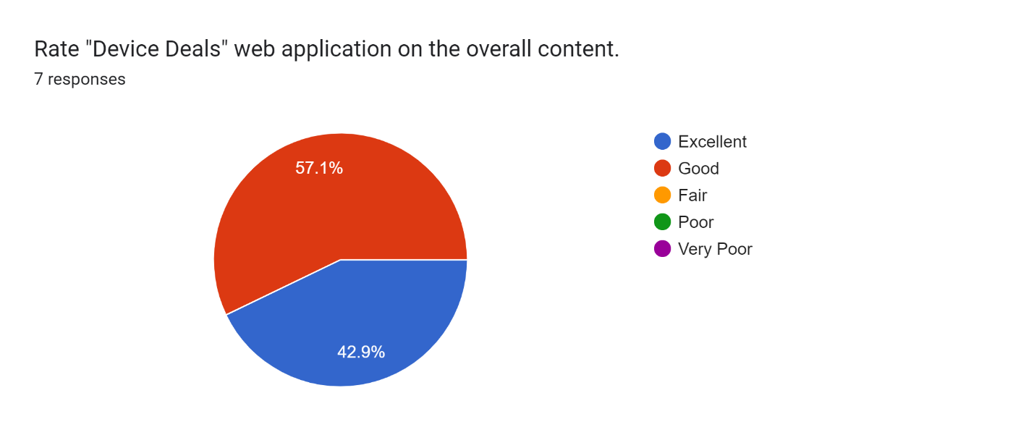

Figure 28: Feedback results 01

As per figure 28, it is clearly visible that all seven respondents were satisfied with the system that everyone rated the system as either good or excellent.

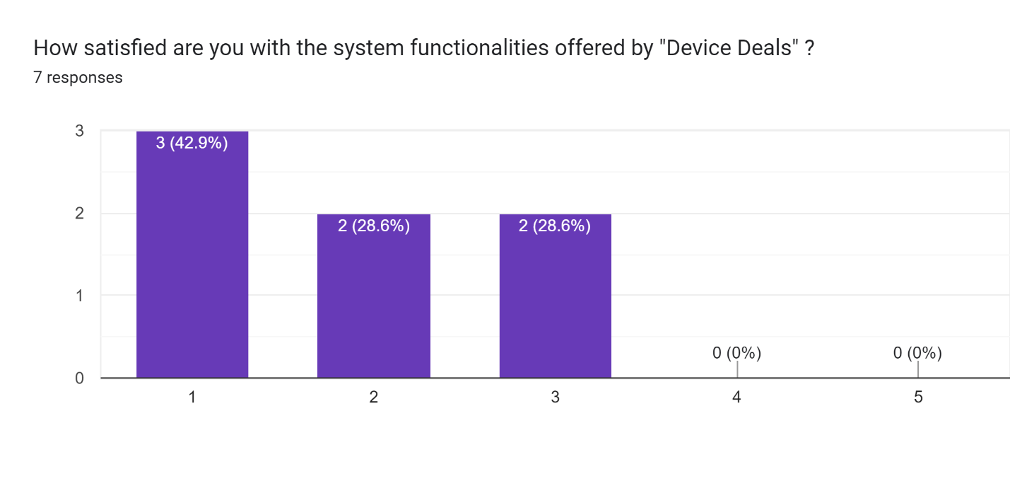

Figure 29: Feedback results 02

As per figure 29, when it was questioned how satisfied the respondents were regarding the system functionalities offered by the web application, the majority said they are very much satisfied and an equal percentage said they are considerably satisfied and are in a neutral position.

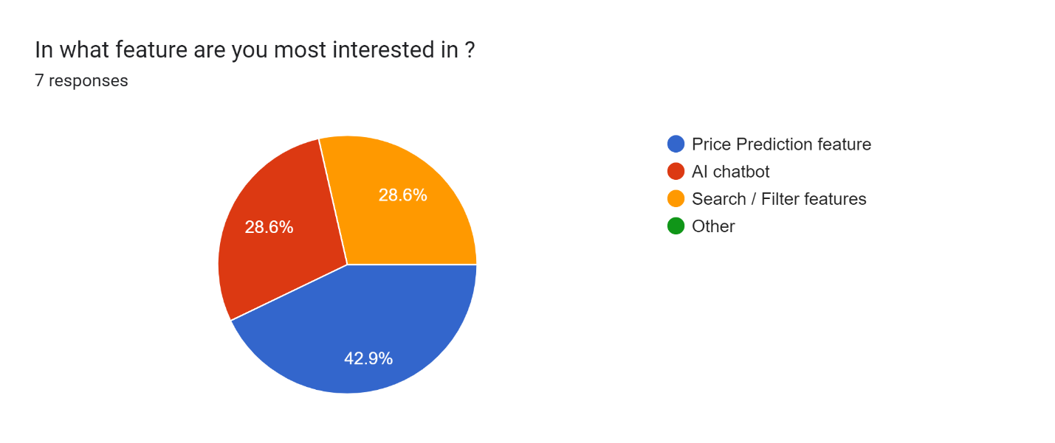

Figure 30: Feedback results 03

As depicted by the figure 30, it is clearly visible that most of the people are interested in the price prediction feature and equal percentage of people are liking the AI chatbot and the search/filter features.

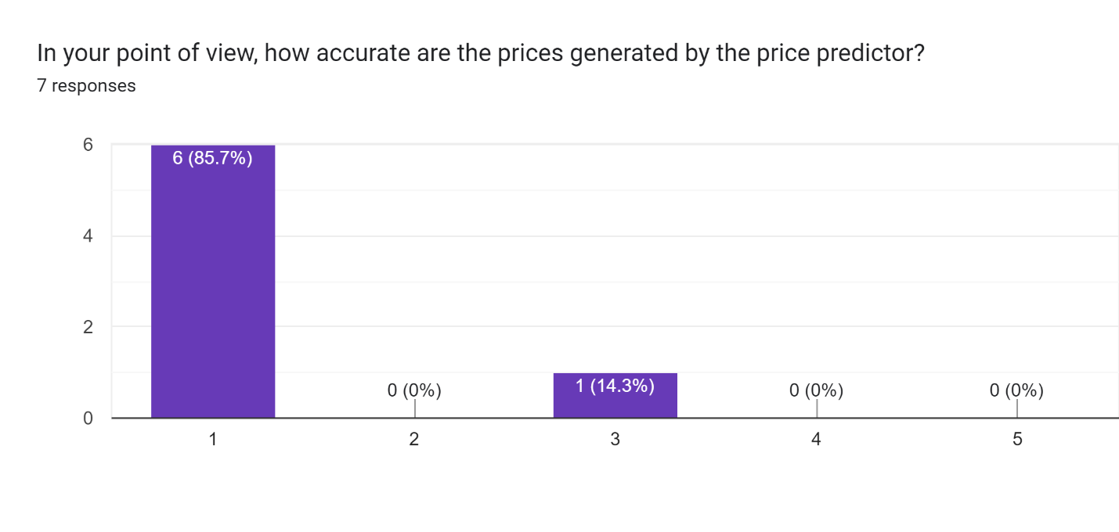

Figure 31: Feedback results 04

According to figure 31, it is clearly visible that, 6 out of 7 respondents have stated that the price prediction done by the price predictor is very much accurate.

# **Conclusion and Future plans**

This chapter, which acts as the report's conclusion, discusses the project's overarching goals and key objectives, as well as its eventual outcomes and plans for the project's continued development in the future. The key objectives of this project were to investigate the usefulness of machine learning in the process of developing web apps and to build a web application that is capable of predicting the prices of used electric items.

The findings of each test that was run during the period of testing the system, as well as the feedback from people who reviewed the system, served as the basis for establishing whether or not the research was successful. It provided evidence that the system was successful in achieving its predetermined aims and goals. Early on in the course of this project, an analysis of existing systems, literature works, and machine learning approaches were carried out. Linear regression analysis which comes under supervised machine learning was chosen as the algorithm for the price prediction feature since it is the most basic and commonly used predictive analysis.

From information gathering, which is the first stage of artifact development, to the last stage, testing and evaluation, the complete research has been fully described. The development and implementation phases were split into 5 phases according to the Agile software development approach, which was used for this study. There was implementation work to be done for each of those 5 sprints, as well as unit testing. There were numerous concerns and problems that needed to be resolved during the course of those five sprints. These challenges and problems were brought on by a lack of prior knowledge of all the technologies and tools employed to create this system. These challenges and issues were resolved, and the system was successfully completed and implemented.

## Lessons learned

Since the learning curve and the research aspect involved in creating this artifact are too extensive to be covered in detail in this document, a summarized version can be provided as below.

* Importance of proper time management.

With the constant power cuts and limited time duration available, completing the work on time was very challenging. To ensure the researcher won’t run out of time, the researcher had to work on strict deadlines and schedules, which taught how to present a decent deliverable even under an immense amount of pressure.

* Planning for the unexpected

When creating the time plan and the Gantt Chart, daily power cuts were not something the researcher ever thought of. Unexpectedly, the researcher had to face 2–3-hour daily power cuts which seriously impacted the deadlines imposed, and as a result, the researcher even had to do alterations to the initial time plan several times. It was learned that it won’t have affected that much seriously if the researcher had allocated a project buffer which is an extra time, we add to a task so that even if it gets delayed, it won’t affect the overall project schedule. The researcher learned that it is essential thing to plan for the unexpected and have at least a 20% buffer time out of the complete project duration as a good practice.

* Importance of proper planning

Since the researcher was aware at the very beginning, that there is a limited time duration of 14 weeks to complete the entire project, it was very well planned for the tasks to be completed. The researcher worked under strict deadlines and completed work on time without post-ponding work. As a result, the researcher was able to deliver almost all the expected deliverables on time without running out of time.

* Importance of seeking support when needed

When establishing the connection between the front-end and the back-end, the researcher faced several issues which were unable to resolve by the researcher on her own. The researcher spent days struggling to figure out the issues all alone but finally decided to get support from some of her friends who were experts on the subject. With their support and guidance, the researcher was able to get all the issues resolved within a short time duration of like 3 hours which finally made her learn that, asking for help when needed is not something to be ashamed of because none of us knows everything.

* Nothing is impossible

In the beginning, when the researcher was thinking about the workload to be completed, it felt like this is merely impossible to be done. The researcher was extremely stressed out and very confused not knowing what to do and where to begin. But eventually, step by step the researcher figured out everything and anyhow finally completed the work which she thought was impossible to be done. Through that, it was learned, that even if the goals and tasks look very complicated when taken as a whole, once broken into small sub-tasks they are less complex and easy to be achieved.

## Limitations

Initially, it was planned to implement the price prediction feature considering all the categories of electric items but later it was identified that it is a very complex process that is impossible to be addressed within the available time duration. Therefore, the price prediction feature was only implemented for mobile phones. In addition to that, the dataset used was only having a few popular mobile phone brands such as Samsung, Apple, Huawei, and RealMe. Therefore, the price prediction feature will only generate prices related to the available mobile phone brands. Apart from that, the accuracy of the predicted price will depend on the accuracy of the dataset and on the size of the dataset. When discussing the chatbot, the chatbot is trained only to provide automated answers to a selected set of questions. Therefore, the users will not get answers to the questions that the chatbot was not trained for.

## Future work

As described in section 6.2, the currently available price prediction feature is only capable of generating predicted prices for mobile phones. Therefore, in the future, it is expected to develop the price prediction feature enabling the users to predict the prices of all the other types of electric items as well. In addition to that, the chatbot is also expected to be developed more, to ensure that, answers will be provided to almost all the questions raised by the users. In addition, it is planned to use a payment gateway in the future and scale the web application to a client-server web application which even allows buyers to make payments through the website and purchase items straight away.

# **References**

Theobald, O., 2017. *Machine learning for absolute beginners: a plain English introduction* (Vol. 157). Scatterplot press.

Jordan, M. and Mitchell, T., 2015. Machine learning: Trends, perspectives, and prospects. *Science*, 349(6245), pp.255-260.

Pedregosa, F., Varoquaux, G., Gramfort, A., Michel, V., Thirion, B., Grisel, O., Blondel, M., Prettenhofer, P., Weiss, R., Dubourg, V. and Vanderplas, J., 2011. Scikit-learn: Machine learning in Python. *the Journal of machine Learning research*, *12*, pp.2825-2830.

Al-Saqqa, S., Sawalha, S. and AbdelNabi, H., 2020. Agile Software Development: Methodologies and Trends. *International Journal of Interactive Mobile Technologies*, *14*(11).

Badillo, S., Banfai, B., Birzele, F., Davydov, I., Hutchinson, L., Kam‐Thong, T., Siebourg‐Polster, J., Steiert, B. and Zhang, J., 2020. An Introduction to Machine Learning. *Clinical Pharmacology &amp; Therapeutics*, 107(4), pp.871-885.

Pudaruth, S., 2014. Predicting the price of used cars using machine learning techniques. *Int. J. Inf. Comput. Technol*, *4*(7), pp.753-764.

Asim, M. and Khan, Z., 2018. Mobile price class prediction using machine learning techniques. *International Journal of Computer Applications*, *179*(29), pp.6-11.

Silaparasetty, N., 2020. *Machine Learning Concepts with Python and the Jupyter Notebook Environment: Using Tensorflow 2.0*. Apress.

Bishop, C.M. and Nasrabadi, N.M., 2006. *Pattern recognition and machine learning* (Vol. 4, No. 4, p. 738). New York: springer.

Richert, W., 2013. *Building machine learning systems with Python*. Packt Publishing Ltd.

A. Varma, A. Sarma, S. Doshi and R. Nair, "House Price Prediction Using Machine Learning and Neural Networks," 2018 Second International Conference on Inventive Communication and Computational Technologies (ICICCT), 2018, pp. 1936-1939, doi: 10.1109/ICICCT.2018.8473231.

Awad, M.A., 2005. A comparison between agile and traditional software development methodologies. *University of Western Australia*, *30*, pp.1-69.

Tziridis, K., Kalampokas, T., Papakostas, G.A. and Diamantaras, K.I., 2017, August. Airfare prices prediction using machine learning techniques. In *2017 25th European Signal Processing Conference (EUSIPCO)* (pp. 1036-1039). IEEE.

S. Velankar, S. Valecha and S. Maji, "Bitcoin price prediction using machine learning," 2018 20th International Conference on Advanced Communication Technology (ICACT), 2018, pp. 144-147, doi: 10.23919/ICACT.2018.8323676.

Sen, J. and Chaudhuri, T.D., 2018, December. Stock price prediction using machine learning and deep learning frameworks. In *Proceedings of the 6th International Conference on Business Analytics and Intelligence, Bangalore, India* (pp. 20-22).

Hristova, Y., 2019. The second-hand goods market: Trends and challenges. *Известия на Съюза на учените-Варна. Серия Икономически науки*, *8*(3), pp.62-71.

Shalev-Shwartz, S. and Ben-David, S., 2014. *Understanding machine learning: From theory to algorithms*. Cambridge university press.

Mahesh, B., 2020. Machine learning algorithms-a review. *International Journal of Science and Research (IJSR).[Internet]*, *9*, pp.381-386.

Müller, A.C. and Guido, S., 2016. *Introduction to machine learning with Python: a guide for data scientists*. " O'Reilly Media, Inc.".

Wrike.com. 2022. *What Is Agile Methodology in Project Management?*. [online] Available at: <https://www.wrike.com/project-management-guide/faq/what-is-agile-methodology-in-project-management/> [Accessed 16 May 2022].

Guru99. 2022. *Unsupervised Machine Learning: Algorithms, Types with Example*. [online] Available at: <https://www.guru99.com/unsupervised-machine-learning.html#:~:text=Unsupervised%20Learning%20is%20a%20machine,deals%20with%20the%20unlabelled%20data.> [Accessed 17 May 2022].

# **Appendices**

## Appendix A

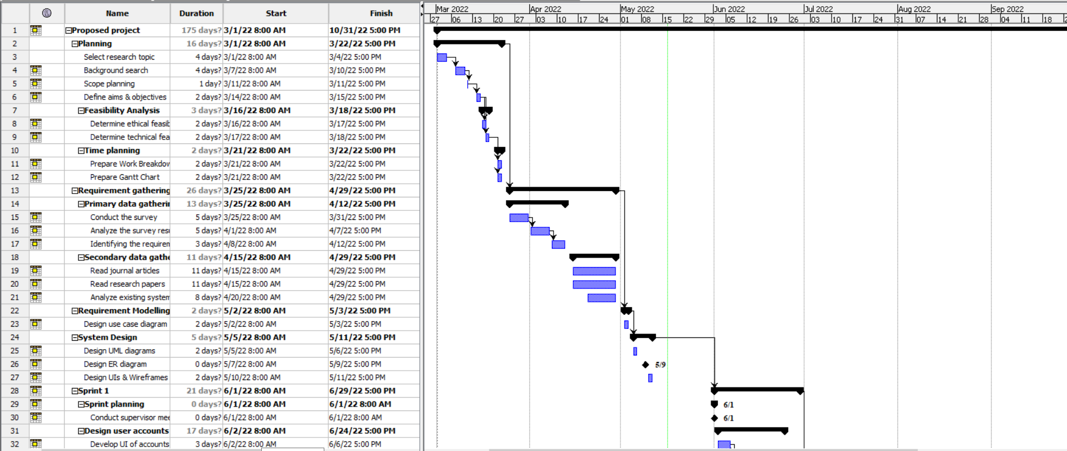

Figure 32: Gantt chart part 1

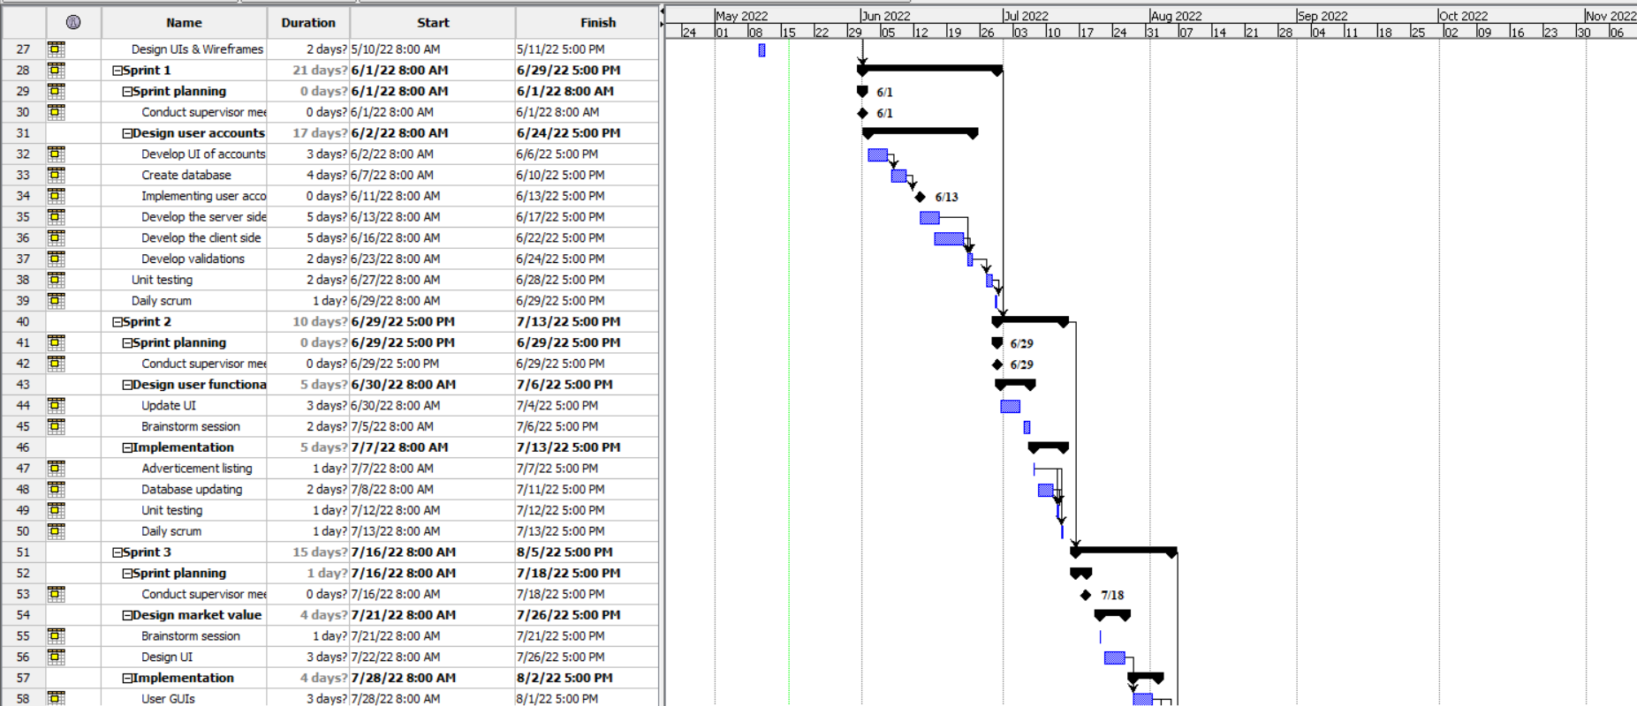

Figure 33: Gantt chart part 2

## Appendix B

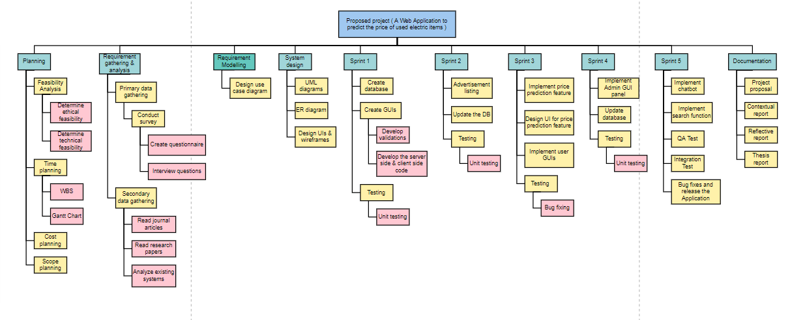

Figure 34: WBS

## Appendix C



Figure 35: Project poster

## Appendix D

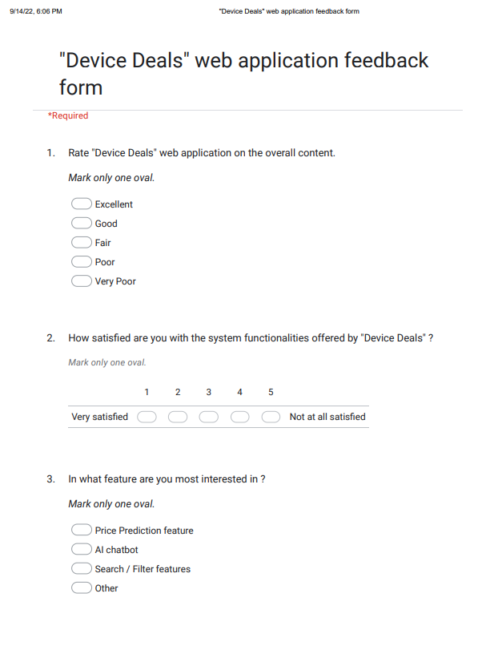

Figure 36: Feedback questionnaire image 1

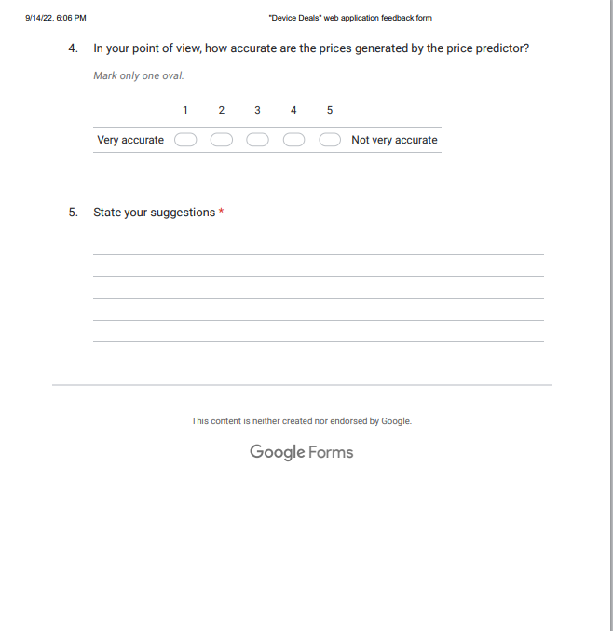

Figure 37: Feedback questionnaire image 2